

Snapcomms

Frequently asked questions

## Can I snooze my Snapcomms messages?

Yes, you can snooze your Snapcomms messages and view them later. This can be done by simply closing out of the Snapcomm pop-up or clicking a “read this later” button when prompted.

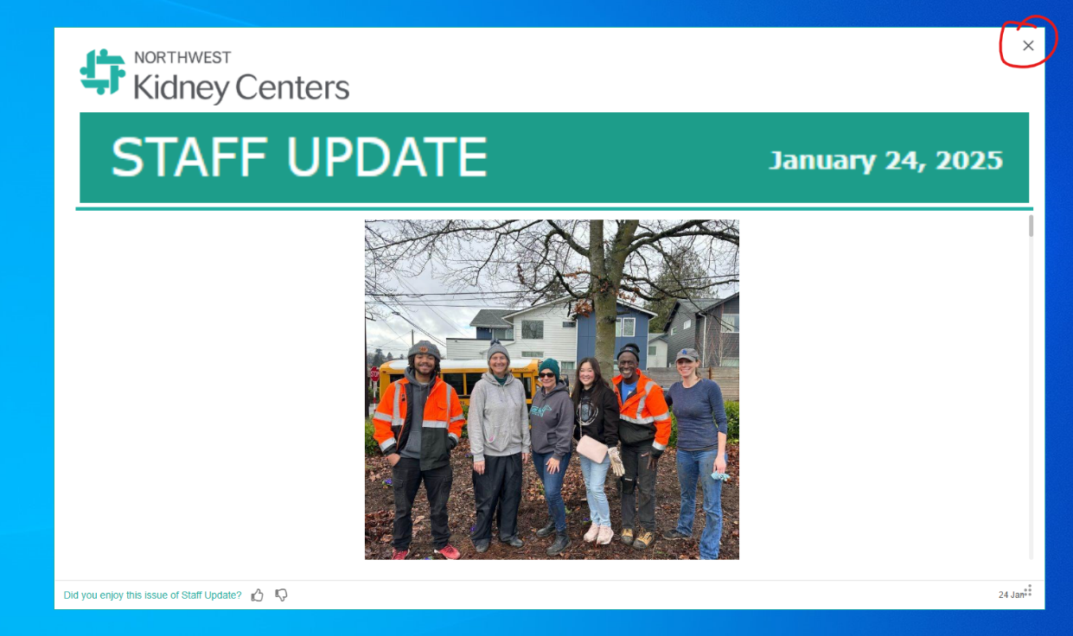

## How can I access the Snapcomms app once I close out of a notification?

You can access the Snapcomms app by finding the app in the application browser or by clicking on the “show hidden icons” carrot (pictured below).

## What does the Snapcomms app look like once it is opened?

Pictured below is what the Snapcomms app looks like when it is opened. You can view all your Snapcomms messages in their inbox and see unread messages in the “Unread” inbox. Just click on the message and it will open in a new window.

## Are Staff Updates available on KNET?

Yes, all Staff Updates are posted on KNET in the news section.

