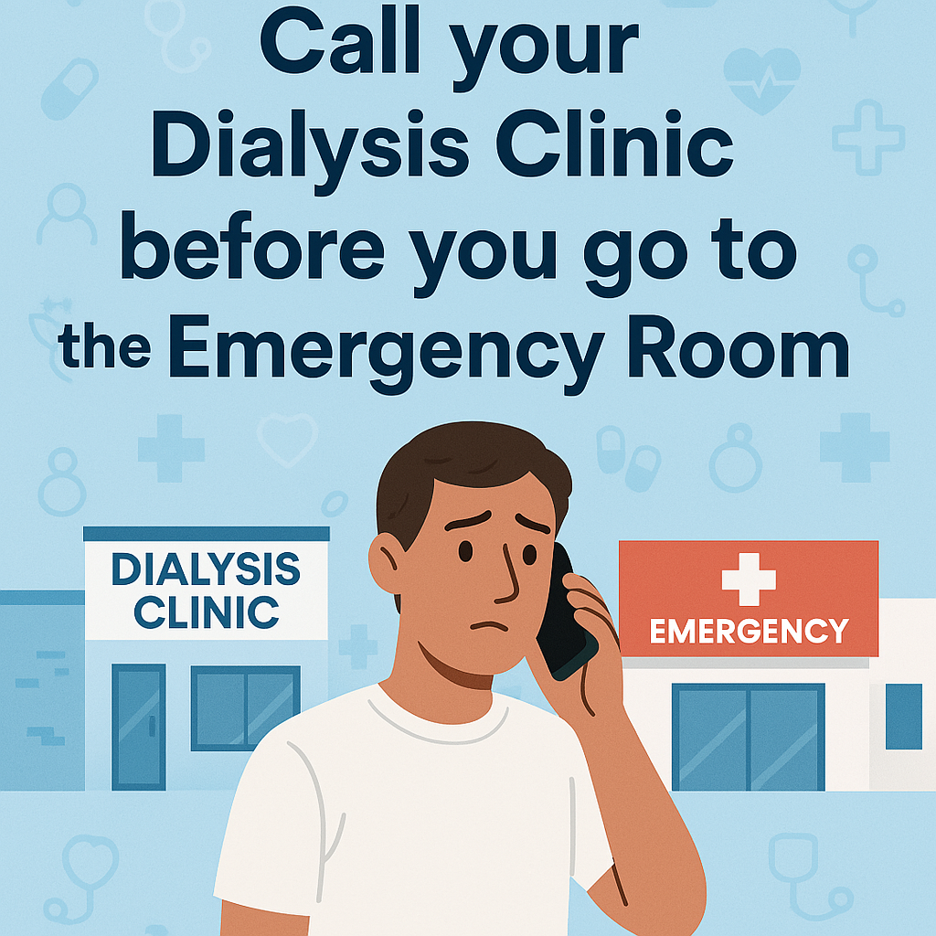
Call Before You Go!!!
Clinic: Renton Kidney Center
Phone Number: 425-251-0647
Speak to a Nurse about your symptoms, if you need dialysis, we may be able to help you faster than the Emergency Room. 

