Clarity Monthly Update

May 2025

General Information
Renvio regularly updates Clarity with fixes to issues reported and enhancements based on user feedback. The following is a general overview of those fixes and enhancements that will be released on Sunday, May 11, 2025. You will see these updates starting Monday, May 12.

What’s New or Fixed in Clarity
- Extended Length of the Pop-up for Time Out Warning, Add a Count Down
  - Renvio extended the potential length of the pop-up warning that appears prior to being automatically logged out of Clarity. A timer will display how much time you have to click the “Keep me signed in” button.
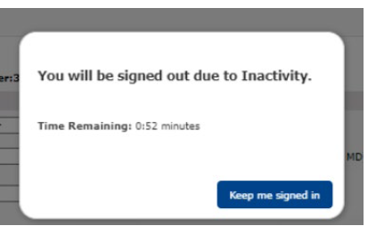

- Update Searching by Name
  - Renvio improved how the patient search function works in Patient Chart View and when creating checklist/patient assessments; all active patients will appear first, and it will look for matches with the patients’ last name first and then look at first name.
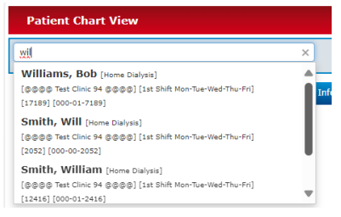

- Medication Form Pulling Inactive Insurance
  - Renvio has fixed a bug with the Medication form when configured to pull Primary Insurance. It will now only be displayed if Primary Insurance is active.

- Real Time Charting – Pre Treatment Tab – Primary Access Assessment
- We have introduced three distinct dressing options for selection during CVC dressing changes.

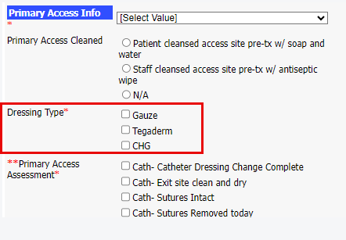

- Dialysis Access
  - We have removed “HD Catheter Temporary” from drop down list because NKC does not allow temporary CVC.

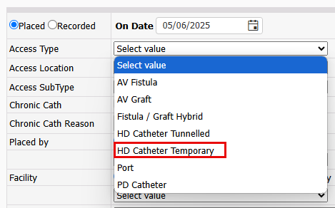

- RTC – Medication Tab Error
  - Renvio fixed the issue where some facilities were receiving an error message on Medication tab in RTC.

- Treatments – Visit Management – Treatment Type -Missed Treatment/Hospitalization
  - Renvio has added Treatment Sub Type Hospitalization option for Missed Treatment.

- Patient Portal-Treatment Summary- Add High/Low BP
  - When treatments are recorded in RTC, Renvio pull the High and Low BP from the treatment into Treatment History and various downstream reports (i.e. BP trends).

  - When treatments are received from Home Hemodialysis patients (such as NxStage machines), Renvio does not show the High and Low BP values. Renvio have added these fields to the following places.

      - Visit Managements HH – The Patient Portal Tx Summary Tab will now show Run High BP and Run Low BP.
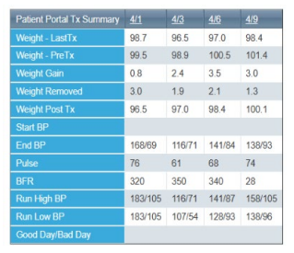

      - Treatment History will also be populated with these values.
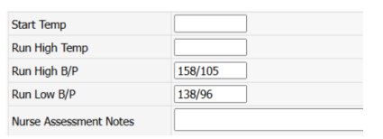

      - Downstream Report such as BP Trends will also show the values.
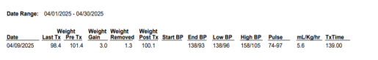

- Patient Header Comments Not Appearing on All Screens
  - In Clarity, we use the Patient Identifier Comments in the header of Clarity screen to identify patients who require Hep B isolation. There was a bug where some pages did not display this value.

  - Renvio has fixed the issue. It can be entered under Registration>General Information>Patient Identifier. Comments should appear on the header of all Clarity pages.
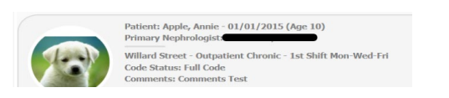

- Clinic History Error
  - Renvio has fixed an issue in Registration>Patient Clinic History. Staff would receive an error unless the Clinic History included a Network Event.

- EQRS
  - Renvio has fixed an issue in the EQRS Patient Submission queue where the filtering by clinic was not working. Now if you filter by a specific clinic, only patients in that clinic will appear.

- Adobe Extension URL Issue
  - Renvio has fixed an issue caused by Adobe Extension that can be installed in user’s browser. The issue was not allowing reports in Organization Management to run as expected due to URL being accessed twice. A modification to Organization Management has been made so the URL for report can be read multiple times.

Clarity Guides and Tip Sheets – On KNET
- Clarity User Guides by Role: K-Net - User Guides by Role (nwkidney.org)
- Clarity Tip Sheets: K-Net - Tip Sheets (nwkidney.org)

