Clarity Monthly Update

November 2024

|  |
| --- |
| General Information |
|  |

Renvio regularly updates Clarity with fixes to issues reported and enhancements based on user feedback. The following is a general overview of those fixes and enhancements that were released on Sunday, November 10, 2024. You will see these updates starting Monday, November 11.

|  |
| --- |
| What’s New or Fixed in Clarity |
|  |

1. **RTC Pre Treatment Hand Crank and Disinfect.**
   * Two elements have previously been added to RTC Pre Treatment tab:
     1. Hand crank present
     2. Has Machine been disinfected.
   * These are now highlighted with red asterisks.
2. **Hover to view lab result details**
   * **In Patient Chart View users can now hover over a result to view more details.**

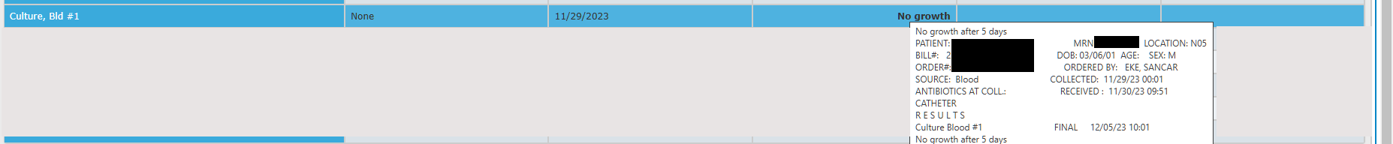

1. **Medication Library Item**
   * There are currently checklist library items that pull a single medication name. These items are now able to pull the different brand or generic names.

* A close up of a computer screen

  Description automatically generated

1. **Billing Worksheet Expanded Report–** 
   * New Medispan orders were not displaying the JA/JB modifier in the Billing Worksheet Expanded report. This is now fixed.
2. **\*Orders by Physician Report**
   * A global preference can now be set to insert Page Breaks between patients. Please submit a request to the IT Service Desk if you wish this function to be turned on.
3. **Medication Strengths missing in Select a Medication Search**
   * Some Medications in Select a Medication search pop-up were missing strengths in the dropdown. Available strengths are now displaying in the dropdown.

1. **Unable to add Non-Standard Medications**
   * An issue where staff were not able to add Non-Standard Medications after the October release has been resolved.
2. **Mircera created Methoxy PEG-Epoetin Beta**
   * In Medication Management updating a Mircera order was creating a new order with the medication name of Methoxy PEG-Epoetin Beta. Updating a Mircera order in Medication Management will now properly create an order with the name Mircera.
3. **Medication Formulary Filter**
   * An issue in which the Medication Formulary filters were not matching the Medication form has been fixed.
4. **RTC – UFR error**
   * A fix for the issue where staff were unable to save UFR greater than 1000 ml in RTC was released 10/7/24.

|  |
| --- |
|  |
| Clarity Guides and Tip Sheets – On KNET |
|  |

1. Clarity User Guides by Role: [K-Net - User Guides by Role (nwkidney.org)](https://knet.nwkidney.org/intra/userguidesbyrole/1561662660362)
2. Clarity Tip Sheets: [K-Net - Tip Sheets (nwkidney.org)](https://knet.nwkidney.org/intra/tipsheets/1561665832956)