Clarity Monthly Update

November 2024

General Information
Renvio regularly updates Clarity with fixes to issues reported and enhancements based on user feedback. The following is a general overview of those fixes and enhancements that were released on Sunday, November 10, 2024. You will see these updates starting Monday, November 11.

What’s New or Fixed in Clarity
- RTC Pre Treatment Hand Crank and Disinfect.
  - Two elements have previously been added to RTC Pre Treatment tab:
    - Hand crank present
    - Has Machine been disinfected.
  - These are now highlighted with red asterisks.

- Hover to view lab result details
  - In Patient Chart View users can now hover over a result to view more details.
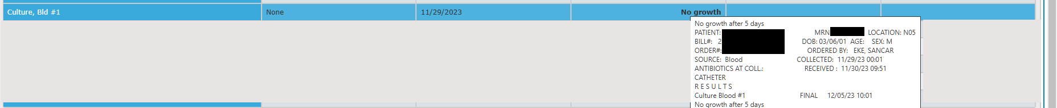

- Medication Library Item
  - There are currently checklist library items that pull a single medication name. These items are now able to pull the different brand or generic names.

- 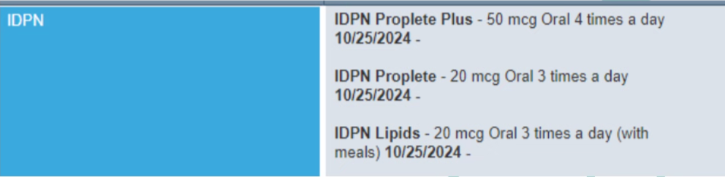

- Billing Worksheet Expanded Report–
  - New Medispan orders were not displaying the JA/JB modifier in the Billing Worksheet Expanded report. This is now fixed.

- *Orders by Physician Report
  - A global preference can now be set to insert Page Breaks between patients. Please submit a request to the IT Service Desk if you wish this function to be turned on.
- Medication Strengths missing in Select a Medication Search
  - Some Medications in Select a Medication search pop-up were missing strengths in the dropdown. Available strengths are now displaying in the dropdown.

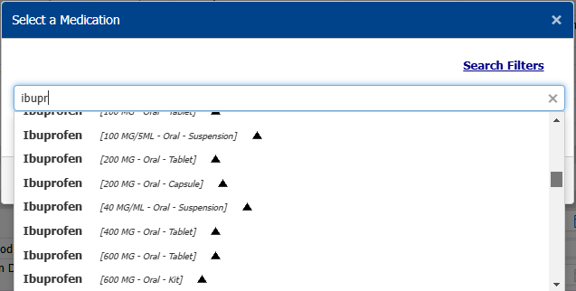

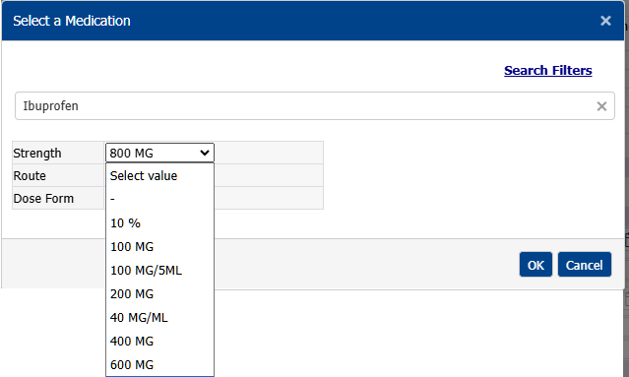

- Unable to add Non-Standard Medications
  - An issue where staff were not able to add Non-Standard Medications after the October release has been resolved.

- Mircera created Methoxy PEG-Epoetin Beta
  - In Medication Management updating a Mircera order was creating a new order with the medication name of Methoxy PEG-Epoetin Beta. Updating a Mircera order in Medication Management will now properly create an order with the name Mircera.

- Medication Formulary Filter
  - An issue in which the Medication Formulary filters were not matching the Medication form has been fixed.

- RTC – UFR error
  - A fix for the issue where staff were unable to save UFR greater than 1000 ml in RTC was released 10/7/24.

Clarity Guides and Tip Sheets – On KNET
- Clarity User Guides by Role: K-Net - User Guides by Role (nwkidney.org)
- Clarity Tip Sheets: K-Net - Tip Sheets (nwkidney.org)

