Clarity Monthly Update

October 2024

|  |
| --- |
| General Information |
|  |

Renvio regularly updates Clarity with fixes to issues reported and enhancements based on user feedback. The following is a general overview of those fixes and enhancements that will be released on Sunday, October 6, 2024. You will see these updates starting Monday, October 7.

|  |
| --- |
| What’s New or Fixed in Clarity |
|  |

1. **Clarity Logon page updated with new Renvio theme.**
   * The Clarity Logon page will look different.

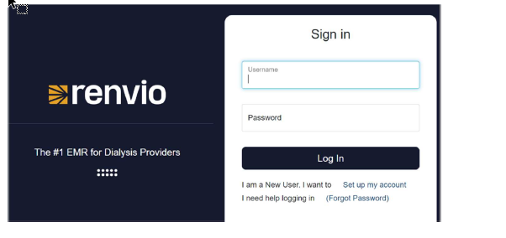

1. **Medication Formulary: Changed from Lexicomp to Medispan**
   * You will see some medication names appear differently
   * Staff can still document treatments using current Lexicomp medication orders.
   * Because Medispan names certain medications differently, they were not able to be automatically changed when the new formulary went into effect.
     1. An example is Mircera’s generic name.
        1. Lexicomp called it: Epoetin Beta Methoxy Polyethylene Glycol
        2. Medispan calls it: Methoxy PEG-Epoetin Beta
        3. If the Mircera dose needs to be changed, the nurse will see this message and the Change Order button will not be available:



* + - 1. If you see this message, you will have to discontinue (End Now) the old order and create a new one by selecting Methoxy PEG-Epoetin Beta from the medication selection screen.
  + Some Medication Route options have changed
    1. Intravenously is changing to **Intravenous**
    2. By Continuous Intravenous Infusion is changing to **Intravenous (Continuous Infusion)**
    3. Into the Affected Catheter is changing to **Intracatheter**
  + Alerts all remain the same
    1. Drug to Drug Interaction
    2. Drug to Allergy Interaction
    3. Medication Dose out of typical Range
    4. Duplicate medication checking.

1. **Allergies**
   * Medication, Medication Class and Other have been updated for Medispan
   * Drug to Allergy Alerts have been updated to include Medication order.

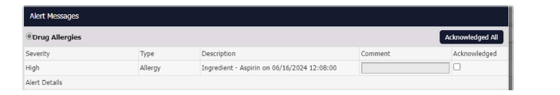

1. **Medication Management/Decision Support**
   * Renvio updated these tools to the Medispan drug ID so they will continue to work as they always have.
2. **Reports**
   * Custom and Standard reports that contain medications have been updated with the new Medispan groups.
3. **Checklists**
   * Library items in checklists that contain medication groups have been updated to pull the new Medispan groups.
4. **Medication Formulary**
   * Clinical Informatics will have to update the Local Formulary list to indicate which medications are given by NKC staff.
5. **Charge Items**
   * Clinical Informatics will have to add charge items for those medication names that are changing to the Medispan form.
6. **Patient Synopsis Incenter report bug**
   * This report has been fixed
7. **2728 Form**
   * Renvio updated the 2728 screen. The Cause of Renal Failure dropdown will update per the Date Regular Dialysis Began. Renvio has limited the form to what crosses to other checklists and reports.
8. **ICD 10 Clarity Terms Catalog Refresh-Data only update**
   * Renvio updated the ICD 10 list for 2025 updates.
9. **RTC-UFR Error**
   * On Sept 9, 2024, Renvio fixed a bug preventing staff from saving a UFR greater than 1000 mL/hr in the Treatment Tab.

|  |
| --- |
|  |
|  |
|  |
| Clarity Guides and Tip Sheets – On KNET |
|  |

1. Clarity User Guides by Role: [K-Net - User Guides by Role (nwkidney.org)](https://knet.nwkidney.org/intra/userguidesbyrole/1561662660362)
2. Clarity Tip Sheets: [K-Net - Tip Sheets (nwkidney.org)](https://knet.nwkidney.org/intra/tipsheets/1561665832956)