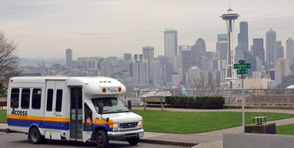

**What are my options?**

* Family/Friends/Caregiver
* Metro Access (must be approved, only runs in King County)
* Hopelink (must have active Medicaid)
* Paratransit (must have active Medicaid, and ride in Pierce County)
* Pierce Shuttle
* Private pay options such as Cab, Uber, etc.
* Public transportation: such as county bus or rail system

**Unsure of what is best for you?**

* Your social worker is a great resource. They can help you figure out what is best for you and help get the process started.

**Important Phone numbers:**

**Your Unit:_______________**­­­­­­­­________

**Metro Access**: (206) 205-5000

**Hopelink:** (800) 923-7433

**Paratransit:** (855) 553-0355

**Pierce Shuttle:** (253) 581-8000

**Clinic’s Responsibilities:**

* Your clinic will help set up standing rides if you are using Metro Access, Hopelink, or Paratransit as your transportation provider.

**Patients Responsibilities**:

* Metro Access, Hopelink, etc. are shared ride services. Meaning your ride may be a short one, but your wait time may be longer. You may arrive early for dialysis or stay longer after you are done.
* Pick up windows are set by the ride share provider, not Northwest Kidney Centers.
* It takes 7 days to set up standing rides or make any changes to the current schedule. During this time, you handle calling your transportation provider until your permanent schedule starts.
* Call your transportation provider if you are going to miss a ride. (excessive number of no-show rides can cause a cancelation of service from your transportation provider)
* If your ride is late, call your transportation provider for an estimated time of arrival.
* Be proactive, have a backup plan, even if you never need it, be prepared.
* Stay as independent as possible making calls.  Only standing rides are done by your clinic.