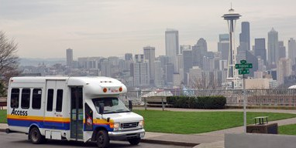



What are my options?
- Family/Friends/Caregiver
- Metro Access (must be approved, only runs in King County)
- Hopelink (must have active Medicaid)
- Paratransit (must have active Medicaid, and ride in Pierce County)
- Pierce Shuttle
- Private pay options such as Cab, Uber, etc.
- Public transportation: such as county bus or rail system
Unsure of what is best for you?
- Your social worker is a great resource. They can help you figure out what is best for you and help get the process started.

Important Phone numbers:
Your Unit:_______________________
Metro Access: (206) 205-5000
Hopelink: (800) 923-7433
Paratransit: (855) 553-0355
Pierce Shuttle: (253) 581-8000

Clinic’s Responsibilities:
- Your clinic will help set up standing rides if you are using Metro Access, Hopelink, or Paratransit as your transportation provider.
Patients Responsibilities:
- Metro Access, Hopelink, etc. are shared ride services. Meaning your ride may be a short one, but your wait time may be longer. You may arrive early for dialysis or stay longer after you are done.
- Pick up windows are set by the ride share provider, not Northwest Kidney Centers.
- It takes 7 days to set up standing rides or make any changes to the current schedule. During this time, you handle calling your transportation provider until your permanent schedule starts.
- Call your transportation provider if you are going to miss a ride. (excessive number of no-show rides can cause a cancelation of service from your transportation provider)
- If your ride is late, call your transportation provider for an estimated time of arrival.
- Be proactive, have a backup plan, even if you never need it, be prepared.
- Stay as independent as possible making calls. Only standing rides are done by your clinic.

