Clarity Monthly Update

July 2024

|  |
| --- |
| General Information |
|  |

Renvio regularly updates Clarity with fixes to issues reported and enhancements based on user feedback. The following is a general overview of those fixes and enhancements that will be released on Sunday, July 7, 2024. You will see these updates starting Monday, July 8.

|  |
| --- |
| What’s New or Fixed in Clarity |
|  |

1. **Visonex rebranded as Renvio**
   * Visonex merged with Renesan and formed/rebranded as Renvio
2. **Renvio Color Scheme**
   * Renvio has updated Clarity’s “look” with the rebranding.
   * Renvio’s colors are a very dark blue and yellow and it is one option that can be selected.
   * NKC has requested to keep the current color scheme of blue and teal.

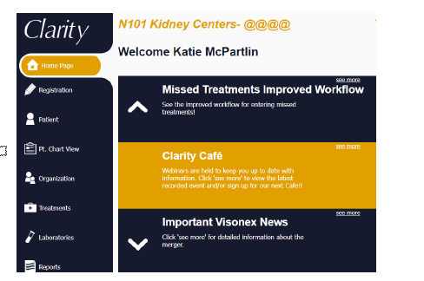

1. **Checklist History-Unable to search by individual patient**
   * Renvio fixed a bug in Patient>Checklist History that prevented users from searching for a specific patient.
2. **Enter Treatments**
   * On June 17 the Enter Treatments screen was retired.
   * Missed treatments should only be entered in Visit Management or Real-Time Charting by entering the Treatment Type, “Missed” and then posting the treatment.
3. **Monthly Labs by lab report**
   * Renvio is gradually updating all reports that include labs to display most recent lab values on the left and older labs on the right.
   * The Monthly Labs by lab report will now display lab values in this format.

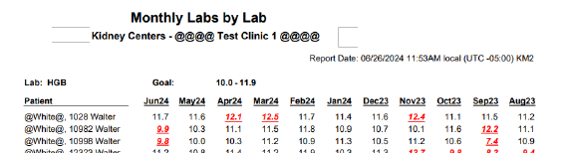

1. **General Information-Patient Identifiers-add other option**
   * NKC can now turn on a function that allows us to add Patient Identifier Comments in General Information.
   * These comments will then display in the Patient Identifier box
   * NKC eventually plans to use this comment box to display for patients who are HBsAg positive and require an isolation room.

1. **Restrict email domains by application**
   * In August 2023 Visonex/Renvio added functionality in Organization Management to only allow certain email domains to be associated with a login account. The issue also affected Patient Portal Users. This can now be disabled for Patient Portal accounts.
2. **Patient Chart View-Displaying Inactive Allergies**
   * Renvio fixed a bug causing allergies that were ended to continue appearing in Patient Chart View (PCV).
   * Now, only active allergies will appear in PCV>Medication tab
3. **Patient Height & Amputation History**
   * The grid will now sort by the Date rather than by Last Updated in the grid.
   * Most recent height will appear at the top of the grid.

1. **Treatment Charting bug with start/stop time**
   * On June 11, 2024, Renvio fixed a bug causing values from the Treatment tab to save in the Start/Stop time fields.
   * **Missed Tx from RTC was not updating as expected or transferring to Tx History**
   * On June 11, 2024, Renvio fixed a bug preventing RTC’s with a treatment type of Missed from posting to Treatment History
2. **Schedule a Billing Run-Second billing run causing a blank screen**
   * Renvio discovered a bug with the last release occurring when scheduling two billing runs in a row.
   * The Billing Interface dropdown was defaulting to Select Value
   * If the user left the dropdown as Select Value, the page would go blank when submitting
   * Now, when submitting a billing run, the page will refresh with CRG listed as the Billing Interface.A screenshot of a computer

     Description automatically generated

|  |
| --- |
|  |
|  |
|  |
| Clarity Guides and Tip Sheets – On KNET |
|  |

1. Clarity User Guides by Role: [K-Net - User Guides by Role (nwkidney.org)](https://knet.nwkidney.org/intra/userguidesbyrole/1561662660362)
2. Clarity Tip Sheets: [K-Net - Tip Sheets (nwkidney.org)](https://knet.nwkidney.org/intra/tipsheets/1561665832956)