Clarity Monthly Update

July 2024

General Information
Renvio regularly updates Clarity with fixes to issues reported and enhancements based on user feedback. The following is a general overview of those fixes and enhancements that will be released on Sunday, July 7, 2024. You will see these updates starting Monday, July 8.

What’s New or Fixed in Clarity
- Visonex rebranded as Renvio
  - Visonex merged with Renesan and formed/rebranded as Renvio

- Renvio Color Scheme
  - Renvio has updated Clarity’s “look” with the rebranding.
  - Renvio’s colors are a very dark blue and yellow and it is one option that can be selected.
  - NKC has requested to keep the current color scheme of blue and teal.

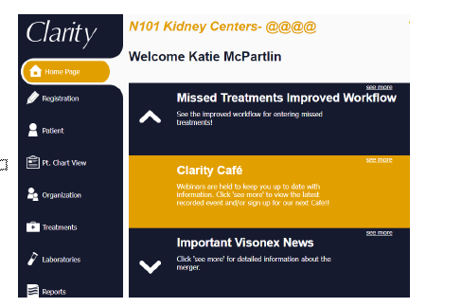

- Checklist History-Unable to search by individual patient
  - Renvio fixed a bug in Patient>Checklist History that prevented users from searching for a specific patient.

- Enter Treatments
  - On June 17 the Enter Treatments screen was retired.
  - Missed treatments should only be entered in Visit Management or Real-Time Charting by entering the Treatment Type, “Missed” and then posting the treatment.

- Monthly Labs by lab report
  - Renvio is gradually updating all reports that include labs to display most recent lab values on the left and older labs on the right.
  - The Monthly Labs by lab report will now display lab values in this format.
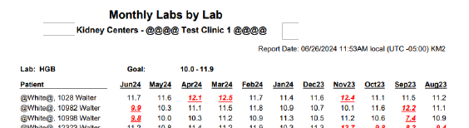

- General Information-Patient Identifiers-add other option
  - NKC can now turn on a function that allows us to add Patient Identifier Comments in General Information.
  - These comments will then display in the Patient Identifier box
  - NKC eventually plans to use this comment box to display for patients who are HBsAg positive and require an isolation room.
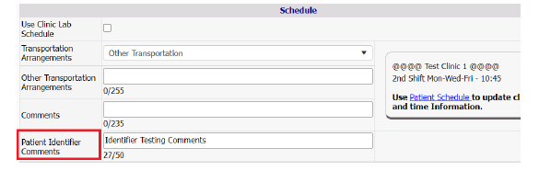

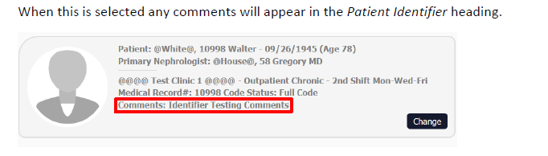

- Restrict email domains by application
  - In August 2023 Visonex/Renvio added functionality in Organization Management to only allow certain email domains to be associated with a login account. The issue also affected Patient Portal Users. This can now be disabled for Patient Portal accounts.

- Patient Chart View-Displaying Inactive Allergies
  - Renvio fixed a bug causing allergies that were ended to continue appearing in Patient Chart View (PCV).
  - Now, only active allergies will appear in PCV>Medication tab

- Patient Height & Amputation History
  - The grid will now sort by the Date rather than by Last Updated in the grid.
  - Most recent height will appear at the top of the grid.
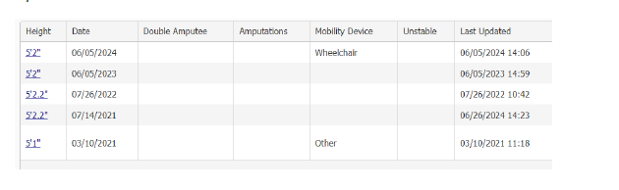

- Treatment Charting bug with start/stop time
  - On June 11, 2024, Renvio fixed a bug causing values from the Treatment tab to save in the Start/Stop time fields.

  - Missed Tx from RTC was not updating as expected or transferring to Tx History
  - On June 11, 2024, Renvio fixed a bug preventing RTC’s with a treatment type of Missed from posting to Treatment History

- Schedule a Billing Run-Second billing run causing a blank screen
  - Renvio discovered a bug with the last release occurring when scheduling two billing runs in a row.
  - The Billing Interface dropdown was defaulting to Select Value
  - If the user left the dropdown as Select Value, the page would go blank when submitting
  - Now, when submitting a billing run, the page will refresh with CRG listed as the Billing Interface.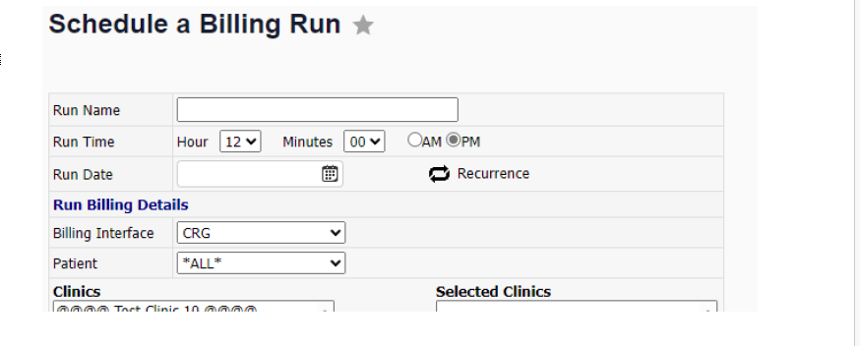

Clarity Guides and Tip Sheets – On KNET
- Clarity User Guides by Role: K-Net - User Guides by Role (nwkidney.org)
- Clarity Tip Sheets: K-Net - Tip Sheets (nwkidney.org)

