Northwest Kidney Centers

Preceptor Training Guide



*“The content of a book holds the power of education, and it is with this power that we can shape our future and change lives.”*

~ Malala Yousafzai

Table of Contents

Introduction 4

Tips for Success 4

Preceptor Checklist for Onboarding New Trainee 4

Preparing For Your New Learner 5

Weekly Educational Topic 7

Get the Learner Involved 8

Smart Goals 8

Kidney Failure Basics 9

Renal Anatomy 9

Functions of the Kidney 10

Causes of Kidney Failure 10

Problems Associated with Kidney Failure 11

Electrolytes and Kidney Failure 11

Principles of Dialysis 13

Terminology 13

Semipermeable Membrane 13

Dialysis solution concentration. 14

Fluid Compartments 14

Fluid Management 15

Hemodialysis Overview & Devices 16

Dialysis Medications 18

Vascular Access 19

Arteriovenous Fistula 19

Arteriovenous Graft 20

Vascular Access Complications 21

Infection Control in Dialysis 23

Hemodialysis Complications 24

Clinical Complications 24

Technical Complications 25

Appendix 26

Classroom Content Overview Grid 27

New Hire Paperwork 29

Communication Styles 31

Empathy Map 32

How To Provide Feedback 32

BOOST Feedback Model 33

Facility Specific Content 33

# Introduction

Congratulations on becoming a Preceptor! You are tasked with the training, onboarding and development of newly hired and experienced staff. The role of the Preceptor is extremely important and necessary for the safe delivery of care in our clinics.

This guide has been developed to assist you in properly training and onboarding new and experienced staff hired to join your team. Each section of this manual compliments the Core Curriculum for the Dialysis Technician 5th edition. During the training and onboarding of new staff utilize this guide to organize, validate and evaluate the onboarding experience for your trainee.

### Tips for Success

* Be empathetic, remember what if felt like to be "new", a trainee.
* Praise in public and correct in private.
* Give positive and constructive feedback in a kind way.
* Start each day with a plan.
* Encourage trainees to ask questions and be open to answering.
* Always be professional.
* Follow the policies & procedures to avoid confusing the trainee.
* Avoid gossip and redirect anyone speaking disparagingly about the trainee.
* Use a variety of teaching techniques during training.
* Actively engage the trainee in learning experiences; avoid "busy work".
* Remember, your attitude is contagious!

The new staff will likely have many of the same emotions and questions you had when you were first learning dialysis. Use the checklist below to prepare for your learner prior to their first day in the unit.

### Preceptor Checklist for Onboarding New Trainee

|  |  |
| --- | --- |
| Calendar Review - Do you have any planned PTO during the training period? |  |
| Copy of Trainee onboarding schedule for offsite classes and clinic days. |  |
| Contact information for the new employee. (Phone number, email, etc.) |  |
| Notify pod of new hire 1-2 weeks prior to first day in the clinic |  |
| Activate patient training partnerships; inform patients about the new hire and introduce them by name. |  |
| Conduct a preceptor-to-preceptor handoff when new hire is going to work with more than one preceptor |  |

It is important for the new learner to feel welcomed at NKC, try to remember when you were the "new" person. What are some ways you can provide a positive experience for the new employee?

This onboarding and training guide for newly hired employees to Northwest Kidney Centers is designed in consideration of the Centers for Medicare and Medicaid Conditions for Coverage, Washington State Board of Nursing requirements and the Core Curriculum for the Dialysis Technicians. Newly hired experienced and inexperienced clinical employees will orient and onboard to Northwest Kidney Centers through asynchronous and synchronous didactic learning and hands-on clinical practice. An inexperienced employee must complete a minimum of 320 training hours (unless otherwise required by the state of Washington) with completion of all onboarding paperwork prior to assuming an independent clinical assignment. New hires with experience will be oriented to their home facility and attend additional training as needed. All new hires will have an assigned preceptor to assist with orientation and onboarding.

There will be specific educational topics and weekly objectives to help guide the training. Each week the preceptor will meet with the orientee and set SMART goals on the first workday. At the end of each week the orientee and preceptor will review the goals, complete any required paperwork, and determine a course of action for the following week. The preceptor will advance through the training curriculum according to the educational sequence when the orientee has demonstrated proficiency in the weekly topics. Communication on the orientees’ progress will be provided to clinical leadership weekly or as needed.

## Preparing For Your New Learner

The table below depicts the didactic training classes offered by the Clinical Education department. Newly hired employees will attend these classes to meet their learning needs and onboarding criteria as outlined in the learning plan. Experienced and inexperienced employees can take advantage of the classes offered. Speak with your manager about the new employees’ didactic training schedule and or if you are interested in attending any of the sessions.

The orientee will follow your work schedule when not attending theoretical learning days. Please speak with your center manager for a copy of the new hire onboarding schedule including the clinical and didactic training days.

***Please note:*** the class schedule is subject to change based on organizational training needs. The grid below is an outline of individual classes offered during the first 8 – weeks of training and onboarding. Note: this grid is for those staff new to dialysis, experienced staff will have a modified training schedule based on their learning needs.

|  |  |  |  |  |  |  |  |
| --- | --- | --- | --- | --- | --- | --- | --- |
| **Week 1** | **Week 2** | **Week 3** | **Week 4** | **Week 5** | **Week 6** | **Week 7** | **Week 8** |
| NEO-in person @Burien | Dialysis 101 (v) | Dialysis 102 (v) | Access (AVF/AVG)  101 | Machine 103 | Nurse 101 (v) | Nurse 102 (v) | Dialysis 104 (v) |
| General Clinical I | Machine 101 |  | Access (AVF/AVG) 102 | Dialysis 103 (v) | Nurse EMR only | Nurse 103 (v) | Dialysis 105 (v) |
| General Clinical II | Machine 102 |  |  |  | CVC 101 |  |  |
| Basic Clarity (new users) |  |  |  |  |  |  |  |

\**An overview of the content taught in each class can be found in the appendix.*

On the first day in the clinic the learner will need to get acclimated to the center and meet the team. If this is the first time the orientee has been employed by a healthcare company the sounds of the dialysis unit may be overwhelming. Reassure your orientee by sharing your first day experience when you were new.

Tasks for the orientee to complete:

* Introduction to the team
* Scavenger hunt
* Observation of the unit activities
* Introduction to patients in preceptor pod
* Relias training classes - Shift change is a great time for the orientee to work on these courses.

Be sure to check - in with your orientee regularly (at least once an hour). A positive onboarding experience can improve retention of new hires by 82 percent!

**Additional Notes**

__________________________________________________________________________________________________

__________________________________________________________________________________________________

__________________________________________________________________________________________________

__________________________________________________________________________________________________

__________________________________________________________________________________________________

__________________________________________________________________________________________________

__________________________________________________________________________________________________

__________________________________________________________________________________________________

__________________________________________________________________________________________________

__________________________________________________________________________________________________

__________________________________________________________________________________________________

__________________________________________________________________________________________________

__________________________________________________________________________________________________

__________________________________________________________________________________________________

__________________________________________________________________________________________________

__________________________________________________________________________________________________

__________________________________________________________________________________________________

__________________________________________________________________________________________________

__________________________________________________________________________________________________

# Weekly Educational Topic

Review the weekly educational topics with your learner prior to crafting the SMART goals. This will allow you and the learner to evaluate if more time is needed in any area prior to moving forward in the training. Remember to share the weekly educational topics, objectives and learner progress or barriers with your manager when you meet weekly (or biweekly in some units). Set a cadence with your manager on the frequency of meetings prior to the new learner’s arrival in the clinic. Your meetings may fluctuate based on scheduling conflicts and the speed in which your learner picks up new skills. Anytime you have concerns about the learner's progress, do not delay notifying your manager.

**Do Not Wait** until the end of training to verbalize the learner is having difficulty grasping the tasks related to their role.

### Get the Learner Involved

New learners are often eager to perform hands-on duties. A quick and easy way to immerse the learner in the daily activities of patient care is with data collection and documentation.

Confirm the learner has completed the Clarity basics class and has access. Have the learner shadow you as you complete the pre-treatment documentation in clarity, intradialytic documentation, and post treatment documentation.

Once the learner has observed 1-2 patients with you have them collect data on a patient providing prompts when needed to ensure all the information is gathered and documented.

Use the SMART goal method to set goals with the new learner aimed at meeting the weekly objectives.

## Creating SMART Goals

SMART goals are important when training new learners because they provide a clear and specific framework for setting and achieving objectives. SMART is an acronym that stands for Specific, Measurable, Achievable, Relevant, and Time-bound. Review the explanation of each element and then use the SMART goal worksheet to create weekly goals with your new learner.

1. Specific: Goals should be clear and well defined. They should answer the questions, who, what, where, when and why. This will help provide clear direction for the new hire.
2. Measurable: Goals should be quantifiable so that progress can be tracked and evaluated.
3. Achievable: Goals should be realistic and attainable. They should challenge the new learner but also be within their capabilities depending on where they are in the training schedule.
4. Relevant: Goals should align with the overall objectives and priorities of the training schedule and organization. The goal should contribute to the learning, growth and success of the new learner.
5. Time-bound: Goals should have a specific timeframe or deadline for completion. This helps in creating a sense of accountability.

By setting SMART goals, new learners can have a clear understanding of what is expected of them and how their performance will be evaluated. It also helps creat a roadmap for success.

### Smart Goals Example

|  |  |
| --- | --- |
| **S** | Specific- Increase the accuracy and timeliness of intradialytic documentation by the new learner |
| **M** | Measurable- Achieve a minimum intradialytic documentation every 30 minutes with 95% accuracy |
| **A** | Achievable- Provide training and resources to new learners to improve understanding and documentation skills |
| **R** | Relevant- Improved accuracy and timely documentation will ensure safety and well-being of patients |
| **T** | Achieve 95% accuracy and consistent timely documentation withing the first 90-days of training |

## Smart Goal Worksheet

|  |  |
| --- | --- |
| S | **Specific: What am I going to do? Why is it important?** |
| M | **Measurable: How will I measure my success? How will I know when I have achieved my goal?** |
| A | **Attainable: How will I carry out the goal?** |
| R | **Relevant: How will achieving the goal help me or the organization?** |
| T | **Time-bound: When will I accomplish my goal? How long will I give myself?** |

# Kidney Failure Basics

## Renal Anatomy

Most people are born with two kidneys although it is possible to be born with just one. The kidneys are located in the retroperitoneal space behind the abdomen on either side of the spine, slightly below the rib cage and shaped like a kidney bean.

**Activity 1:** Make a tight fist, this is roughly the size of your kidney.

**Activity 2:** Place your hands on your back with thumbs facing forward just above your waist. This is the proximal location of your kidneys.

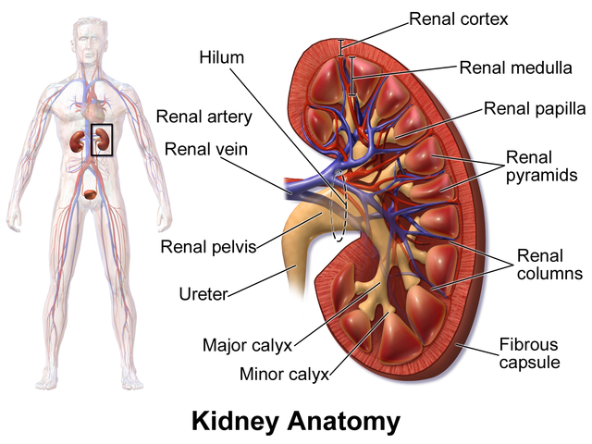

Image credit <https://en.wikipedia.org/wiki/Kidney>

**Fun Fact:** The right kidney is just a bit higher and smaller to make room for your liver.

The kidney is one of the filters within the body and blood flows through your kidneys with each heartbeat. Blood flows through the capillary blood vessels to the nephrons (also known as filters within the kidney). There are about one million tiny nephrons in each kidney. Each nephron is made up of a glomerulus, a tiny filter, which is connected to a tubule.

The capillary blood vessel walls are semipermeable membranes. Like a filter there are pores along the wall of the vessel that allow small particles or substances to pass through.

**Activity:** Let's make coffee! Grab your coffee grounds, water, filter, and a cup. Your kidney’s function like the coffee maker. The freshwater flows over the coffee grounds and passes through the filter as liquid coffee. The filter keeps the coffee grounds from getting into your cup.

What happens when there is a tear in the filter?

## Functions of the Kidney

The kidney’s primary job is to maintain homeostasis (also known as balance) of fluid and chemicals in the body. There are five key functions performed by the kidney to maintain homeostasis in the body.

* Waste removal
* Balance water and electrolytes
* Control blood pressure
* Production and release of hormones
* Acid-base balance

## Causes of Kidney Failure

The prevalent causes of kidney failure are diabetes and hypertension (high blood pressure). Glomerular disease and autoimmune disorders such as polycystic kidney disease or PKD can also cause kidney failure. There are two types of diabetes, however Type 2 diabetes is the number one cause of kidney failure in America. In type 2 diabetes there is not enough insulin produced by the pancreas or the body is unable to use the insulin made properly.

Why does Diabetes cause kidney failure? Diabetes damages the heart, blood vessels and nerves in the body. Remember,the nephrons filter the blood through the glomerulus which is a cluster of tiny blood vessels. When the blood vessels are injured the ability to filter excess waste and fluid is also diminished.

The second major cause of kidney disease is high blood pressure. High blood pressure can also harm the blood vessels and the glomeruli. It is a treatable disease however many people do not have any symptoms and therefore do not seek treatment. Lack of treatment to control the blood pressure increases the likelihood of kidney failure due to the damage high blood pressure can cause on the blood vessels.

Glomerular diseases include glomerulonephritis, an inflammation of the glomeruli and glomerulosclerosis, the hardening of the glomeruli.

Genetic disorders like Polycystic kidney disease can cause the kidneys to fail due to the grape-like cysts growing on the kidneys decrease the amount of healthy tissue.

### Problems Associated with Kidney Failure

**Uremia** – the accumulation or buildup of waste in the blood. Symptoms include swelling (Edema), difficulty breathing, foamy urine, metal taste, nausea, vomiting and some people experience pain around the area of the kidneys.

**Activity:** Ask the orientee why some of these symptoms may occur in individuals with kidney failure. The goal is to have the learner critically think about the functions of the kidneys and which function failure may cause the different symptoms.

*\*Reference Table 2: Uremia symptoms and causes, pg. 25 of the Core Curriculum for Dialysis Technician*

**Anemia - A shortage of red blood cells.** When the kidneys are healthy the hormone erythropoietin (EPO) is produced to stimulate the bone marrow for the creation of red blood cells. In kidney failure, the kidneys produce less hormones which decreases red blood cell reproduction.

**Activity 1:** What are some common symptoms to look for when a person has anemia?

* Fatigue
* Feeling cold
* Pale fingernail beds

**Activity 2:** Identify 3 things you can do to help your patient who may have anemia.

* Always rinse back as much blood as possible after each treatment.
* Properly tap needles to avoid dislodgement and blood loss.
* Inform your nurse about unusual bleeding or blood loss.
* Encourage your patients to come for every treatment and stay the full time.
* Ask your patients if they have had any bleeding at home.
* Proper handling of lab tubes after blood draws.

**Nerve Damage (Neuropathy) -** Peripheral neuropathy or nerve damage in the hands and feet may occur over time especially individuals with diabetes.

**Activity 1**: What disease is commonly known to cause nerve damage and kidney failure?

**Activity 2:** Identify symptoms to look for when a person has neuropathy.

* Burning sensation in hands and feet
* Tingling, "pins and needles" feeling (like when you feel like your leg is numb)
* Muscle weakness
* Unsteady gait, difficulty walking

### Electrolytes and Kidney Failure

Electrolytes carry electrical current throughout the body and are found in cells and body fluids. Healthy kidneys can balance the electrolytes in the body. Individuals with kidney failure are at risk imbalances.

Sodium (Na+) helps maintain water balance in the body.

Potassium (K+) is needed to help control nerves and muscles. With adequate dialysis and proper nutrition, the serum potassium range should be between 3.5 and 5.5 mEq/L.

**Activity 1:** Discuss the importance of patients being on the proper dialysate prescription and how diffusion works to balance the potassium levels in the body. Ask the new learner the following questions to validate learning comprehension.

* **What muscle would you be most concerned about if there is an imbalance of potassium in the body?** The heart.
* **What is a common cause for someone with kidney failure to have too much potassium in the blood?** Eating potassium rich foods or missing treatments. **Why?** The kidneys are unable to excrete the excess allowing potassium build up in the blood. During dialysis excess potassium can safely be removed from the blood aiding in the electrolyte balance in the body.

Calcium (Ca++) assists with nerve transmission, muscle function, release of hormones and blood clotting. The majority of the body's calcium, 99% of it, is stored in bones and teeth.

Phosphorus (P) is an essential mineral mainly found in the bones and teeth. It is naturally present in most foods consumed. What is a common side effect of too much phosphorus in the blood? *Itching*

**Activity 2:**  What prefixes are used to identify if someone has too many or too little electrolytes in the body? Hyper (too much) and Hypo (too little).

**Activity 3:** Discuss with the orientee the importance of patients being connected to the proper dialysate. This is a good time to confirm understanding of dialysis principles of diffusion and osmosis.

Review the common dialysis blood tests with the orientee. Use the Core Curriculum for Dialysis Technicians, Table 3 on pages 31 - 32.

**Activity 4: Test Your Knowledge (answers on pg. 30, Core Curriculum for Dialysis Technicians)**

What single monthly test measures the dose of dialysis?

If you want to measure bone mineral balance which two lab tests are commonly drawn?

Serum albumin is a measurement of ___________ in the blood.

# Principles of Dialysis

Understanding the principles of dialysis is important to being able to critically think through common machine alarms and complications. Hemodialysis is a very complex process, however once you understand the key principles it will be easier to troubleshoot and understand the rationale for prescription changes. Plus, you will be able to better educate your patients on the importance of treatment adherence.

Terminology to review with your learner.

**Gradient**, the difference. A concentration gradient is the difference in the level of solutes between two fluids kept apart by a semipermeable membrane.

**Solution**, a mixture of a solvent (fluid) and a solute (a substance that can be dissolved). Examples of a solution: Sea water, dialysate. Can you think of any other solutions?

**Solubility** refers to how well a solute dissolves in a solvent.

**Diffusion** is a scientific principle in which solutes move back and forth across a semipermeable membrane on their own based on the concentration of the two solutions.

Activity 1: Ask the orientee to give you an example of a solution.

Activity 2: What factors affect the solubility of a solution? *When the solution is saturated with a solute the solution will not dissolve, this is defined as concentration. The pH and temperature can also impact the solubility.*

### Semipermeable Membrane

### 

Only allowing some particles to pass through the thin tissue (membrane). The membrane has small holes throughout that allow the particles to pass through.

Activity 1: Identify different types of common semipermeable membranes. (i.e., skin, window screen, coffee filter, etc.)

Activity 2: Demonstrate the semipermeable membrane using a cup, rubber band, piece of screen, coffee grounds, sugar, and water. Place the screen over the cup and secure with a rubber band. Try pouring the different substances over the screen and discuss why some substances quickly cross the membrane and why.

Question: When does the movement of solutes end?

Answer: Once the concentration on both sides of the membrane is the same.

Activity 1: Using 2 tea bags. Place one tea bag in a cup of warm water and one tea bag in a cup of cool water. Discuss what happens.

Activity 2: Discuss how diffusion occurs during dialysis. What particles are moving? Do particles move from high concentration to lower concentration or from low concentration to higher concentration? Where is the semi-permeable membrane located?

### Dialysis solution concentration.

Hypotonic - there is a lower level of solutes in the solution than in the blood.

Isotonic - solute levels are equal in the solution and the blood.

Hypertonic - a higher level of solutes in the solution than in the blood

**Activity 3:** Why does temperature impact the rate of diffusion?  *Warm molecules move faster than cold ones.*

Does the size of the molecule matter in the rate of diffusion? Why? *Molecule size is important and depending on the pore size of the membrane larger molecules may move slower across the membrane or not at all. An example of a medium size molecule that diffuses slowly in dialysis is phosphorus. What is an example of a molecule that doesn't diffuse during dialysis?*

**Osmosis** is the movement of fluid (solvent) through a semipermeable membrane from an area of lower solute concentration to an area of higher solute concentration.

Activity 1: What is an example of osmosis?

**Filtration** fluid being pushed through a filter by hydraulic pressure. Fluid always moves from higher pressure to lower.

**Ultrafiltration (UF)** is the use of pressure to force fluid through a membrane. This is the method used to remove water from the blood during dialysis. The water is pushed across a semipermeable membrane.

**Transmembrane Pressure (TMP)** is calculated by the dialysis machine. The pressure in the blood compartment is higher than the dialysate compartment thus pushing water out of the blood into the dialysate.

Activity 1: Using a sponge and a cup of water. Place the sponge into the water and discuss what happens. Take the sponge out of the water and squeeze the water out. What transport mechanism is demonstrated?

### Fluid Compartments

Intracellular - fluid inside the cells. 70% of the body's water is inside the cells.

Extracellular - outside the cells, which includes the interstitial space and intravascular space.

Interstitial - is the space in between cells, about 20% of body water.

Intravascular- space inside the blood vessels, about 10% of body water

Activity 1: Review content on Fluid Compartment and the movement of urea in dialysis on pages 75-76 in the Core Curriculum for Dialysis Technician.

What transport mechanism removes the waste from the blood? Does this mechanism help maintain homeostasis (balance) in the body?

What material separates the blood from the dialysis concentrate?

Estimated Dry Weight (EDW) - weight of a dialysis patient without extra fluid in the blood.

Activity 2: Discuss EDW, how it is calculated and why it is so important. *Note: every time the EDW is not achieved a reason must be documented in the patient chart on the day of dialysis and the charge nurse notified.*

# Fluid Management

Fluid management is a delicate balance between sodium (salt) and water in hemodialysis patients. It is a consistent quest to establish a therapeutic dry weight and decrease fluid related cardiovascular complications.

Hypervolemia- is too much fluid volume in the body. It is also known as fluid overload, it can cause swelling and other symptoms like high blood pressure, shortness of breath, rapid weight gain, diminished lung sounds, and heart problems such as congestive heart failure. Some patients with kidney failure may have residual function and continue to excrete excess fluid during urination although the kidneys are not adequately filtering toxins or excess waste. Proper monitoring, patient education and prescribed treatment adherence is important to fluid management and interdialytic weight gain.

**Activity 1:** Define and discuss the dry weight. The dry weight is the patient’s weight without excess fluid. It is measured and calculated in kilograms. One kilogram is the equivalent of 2.2 pounds.

**Activity 2:** Discuss the difference between a target weight and dry weight.

*Target weight is the weight for a given dialysis treatment. Often determined by the dry weight. The target weight may also be used when the physician challenges a patient’s dry weight to establish a new weight.*

Fluid restriction may vary from patient to patient and is determined by the physician considering several factors such as urine output, blood pressure, and cardiovascular condition. In order to calculate the fluid removal goal, it is important for the patients to be weighed properly pre and post treatment. Keys and any heavy outerwear should be removed prior to weighing. Patients should ensure the scale reading is zero prior to stepping onto the center of the scale. A trained caregiver should visualize the scale reading when possible, however some scales have a printer, and the weight can be printed and given to the caregiver chairside.

**Activity 3:** Review the scenario below with your learner and demonstrate how to calculate the fluid removal for patients in your pod.

Joanne is a 65-year-old female is a two-time kidney transplant recipient with Polycystic Kidney Disease. She receives hemodialysis three times a week (Monday, Wednesday, and Friday). Her dry weight is 160 lbs. On a Monday pre-treatment, her weight is 167 lbs., indicating the need for fluid removal.

Calculate the weight removal in kilograms.

What education can be provided to Joanne about her weight interdialytic weight gain?

**Activity 4:** Instruct the learner to calculate the fluid removal goal for each patient in your pod.

# Hemodialysis Overview & Devices

Dialysis removes excess water and waste along with helping to maintain electrolyte and pH balance at a safe level. Dialysis can't fully replace the function of healthy kidneys.

There are four (4) areas of the dialysis system that are vital to the safe and effective treatment of patients. Spend time reviewing each component with your new learner. As you explain, the various components build upon the existing knowledge of the principles of dialysis.

**Dialyzer -** thousands of hollow fibers make up the semipermeable membrane. A plastic housing or case holds all the fibers together and has ports for blood and dialysate to flow in and out during the treatment.

The blood compartment is on the inside of the hollow fibers and the dialysate compartment is on the outside and around the fibers.

The potting material on each end of the dialyzer housing holds the semipermeable fibers open allowing blood to enter and flow through the fibers.

The type of dialyzer is included in the dialysis treatment orders. There are different size dialyzers. The membrane surface area is associated with the size of the dialyzer.

**Activity 1:** Utilizing the preceptor kit contents, visualize the fibers of the dialyzer and discuss the two compartments (blood side and dialysate side) with the learner. Validate comprehension of the need for the separation and how the semipermeable membrane

**Activity 2:** View a dialyzer (while in the package or prior to set up). Ask the learner to point out the blood port in/out, dialysate ports in/out, potting material.

**Knowledge check!** Ask the learner why counter current flow between the blood and dialysate is important. *Countercurrent flow maximizes the waste and fluid removal process during dialysis by maintaining a concentration gradient.*

**Dialyzer characteristics**

The structural characteristics of the dialyzer are considered by the physician when prescribing a particular type and size dialyzer for dialysis. Discuss the characteristics with your learner and possible concerns to consider when caring for patients.

* Biocompatibility - how the body reacts to the membrane.
* Surface area - how large is the membrane. Discuss concerns if the dialyzer clots or if using a large membrane on a smaller patient or new patient to dialysis. How does the larger surface area impact solute and water removal?
* Molecular weight cutoff - this is specific to the size of the solutes that will be capable of crossing the membrane.
* Ultrafiltration coefficient - determines how much water will be removed. *The ultrafiltration coefficient is also known as the KUF  and is not a set number. The KUF helps to predict how much water is removed during the treatment per hour at a given transmembrane pressure. Remember, the high pressure in the blood compartment pushes water out of the blood. Review TMP if needed with learner.*
* *Mass Transfer Coefficient (KoA -* is how well the solutes will cross or pass through the semipermeable membrane.  *Higher KoA means the membrane is more permeable. What are two reasons a dialyzer would be more permeable?*
* *Clearance -* the amount of blood that can be cleared of a solute in a given time at certain blood and dialysate flow rates.

**Convection** - also known as solute drag. This is the removal of larger solutes by being pulled across the semipermeable membrane in their solvent by ultrafiltration.

The dialyzer membrane can affect solute transport. Synthetic membranes are made of long strings of plastic. *Remember how the fibers looked like tiny noodles or straws when viewing through the microscope?*  The synthetic fibers have a good biocompatibility and are highly adsorptive (proteins from the blood stick to the membrane).

**Activity 3:** Tour the supply area and look at the dialyzers used.

* What type of dialyzer fiber is used in your center?
* Do you have multiple dialyzer types?

**Dialysate**

Dialysate is a fluid made up of acid concentrate, bicarbonate concentrate and treated water. This fluid matches the osmolality of the blood very closely to prevent too much water from crossing the semipermeable membrane in the dialyzer. The dialysate flows on the outside of the fibers of the dialyzer inside the membrane housing.

The dialysate is part of the dialysis prescription ordered by a physician. Treated water is the main component of the dialysate mixture combined with various electrolytes and solutes like sodium, potassium, magnesium, calcium, chloride, glucose, bicarbonate, and an acidifier such as acetate or citrate.

The dialysate sodium levels can be changed during treatment to help patients tolerate more ultrafiltration with fewer side effects such as low blood pressure or cramping. The sodium increases in the dialysate causing more sodium to diffuse across the membrane. This practice is known as **Sodium Modeling**.

Knowledge Check: Discuss the following with the learner. ***If the sodium in the dialysate diffuses into the blood how will this action help decrease side effects such as drops in the blood pressure or cramping?*** *When there is an increase in the sodium level of the blood excess water from inside (intracellular) and between(interstitial) the cells will shift into the bloodstream. The fluid removal during dialysis is from the bloodstream (intravascular space).*

The Association for the Advancement of Medical Instrumentation (AAMI) has symbols to find the correct concentrates to use for your machine set up. It is important to always use the correct concentration proportioning ratios to produce safe dialysate for treatment.

**Activity 1:** Show the learner where to find the label for the dialysate on the acid concentrate (drum or single use jug)

**Activity 2:** Discuss the following with your learner.

* Your patient’s potassium lab value for the month was 5.7 mEq/L. The physician ordered a change in the dialysate potassium concentration. A normal potassium value is 3.6 – 5.5 mEq/L.
  + Which principle of dialysis causes a shift in solutes like potassium?
  + What kind of dialysate would you expect the physician to prescribe for this patient?
  + Who can change the patient’s treatment orders in your center?

# Dialysis Medications

People with kidney failure take a lot of medication to manage their disease. Medications are prescribed by the physician and may or may not be the Nephrologist. Some medications are administered during the dialysis treatment and other medications are taken at home. Depending on your state and the scope of practice for your role medication administration may be allowed. In most states only a nurse can administer medications, however there are a few exceptions depending on the state regulations.

You may or may not be allowed to administer certain medications depending on your role in the clinic, however it is important that you understand the importance and function of the medications commonly prescribed for patients with kidney failure.

**Erythropoiesis-stimulating agent (ESA)** is used to treat anemia. The ESA stimulates the bone marrow to reproduce red blood cells. Common medications include Epogen, Mircera, Procrit and Aranesp.

**Iron supplements** can be administered orally or through an IV infusion. This mineral helps the body make red blood cells. Commonly used medications include Ferrlicit, Venofer

**Sodium Bicarbonate** - helps to balance acid levels in the body. Commonly used to treat metabolic acidosis due to the kidneys not excreting excess acid in the urine.

**Phosphate binders** – help to rid the body of extra phosphorus in the blood. Excessive phosphorus in the blood can weaken the bones. There are a variety of binders on the market today to include Renagel, Phoslo,

**Calcium and Vitamin D** - are supplements that help support bone health. Common medication includes Zemplar, Hectorol, and Sensipar.

**Activity 1:** Discuss the state regulations on who can administer medications in your center.

**Activity 2:** Discuss the importance of patients receiving their prescribed medications during the treatment and adherence to their home medication regimen. How does medication impact patient outcomes?

**Additional Notes**

__________________________________________________________________________________________________

__________________________________________________________________________________________________

__________________________________________________________________________________________________

__________________________________________________________________________________________________

__________________________________________________________________________________________________

__________________________________________________________________________________________________

__________________________________________________________________________________________________

__________________________________________________________________________________________________

__________________________________________________________________________________________________

__________________________________________________________________________________________________

# Vascular Access

The lifeline for patients receiving hemodialysis treatment is the vascular access. Without a functioning vascular access, hemodialysis treatment is not possible. Poorly functioning accesses may prevent adequate dialysis causing a patient to have symptoms such as uremia, fatigue or nausea and vomiting. Fistulas, grafts, and central venous catheters are the three main types of vascular access. Review the different access types with your new learner and complete the activities.

### Arteriovenous Fistula

Arteriovenous Fistula (AVF) is the surgical connection of an artery and vein beneath the skin. Most often placed in the arm. The high-pressure blood flow from the artery thickens the wall of the vein it is connected to and causes the vein to grow or dilate to support large hemodialysis needles.

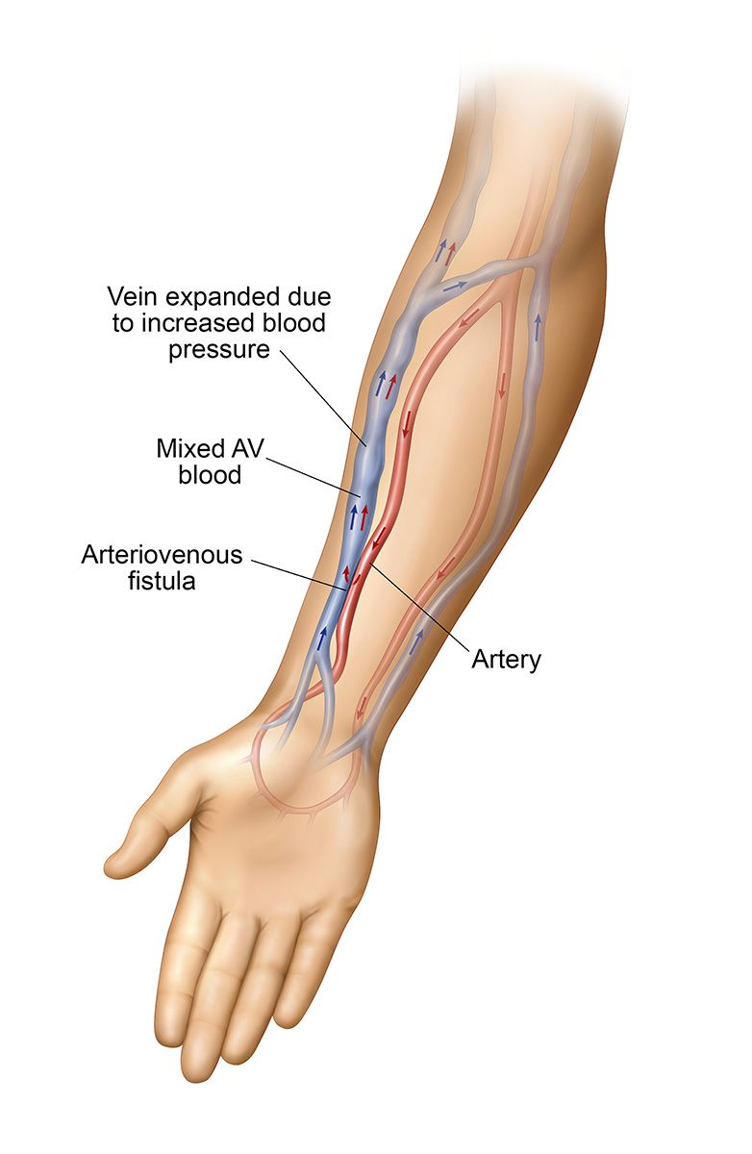

Arteriovenous Fistula

According to KDOQI guidelines it is recommended to place the fistula close to the wrist of the patient. This would be a radial cephalic fistula is the connection between the radial artery and cephalic vein.

Patients are encouraged to do exercises to help the fistula mature like squeezing a rubber ball. It is important that patients do not use the arm with the fistula for monitoring blood pressure to avoid occluding the access.

Activity 1: Review the Look, Listen, & Feel - AVF/AVG Assessment policy (CD-A1126C) with the learner.

Activity 2: Demonstrate how to determine the arterial end of the fistula then have the learner feel the thrill and listen to the bruit. Discuss why it is important to know which end is the arterial side.

Activity 3: Discuss the importance of using a tourniquet and rotation of puncture sites when cannulating a fistula. Review Guidelines for Punctures (HDP-G19023) and Fistula Needle Insertion Procedure (HDP-N19025)

Activity 4: Discuss and demonstrate the technique for access preparation and proper angle for cannulation of an AV fistula.

Photo credit: [Azura Medical](https://northwestkidneycenters-my.sharepoint.com/personal/ercelene_kinnebrew_nwkidney_org/Documents/AV%20Fistula%20Creation%20for%20Dialysis%20|%20AV%20Fistula%20Placement%20(azuravascularcare.com))

The fistula is still considered the "gold standard" for hemodialysis vascular access and can last a very long time with fewer problems such as infection or thrombosis (clotting). The maturation time however is often viewed con, and the fistula can also fail to mature for various reasons like selected vessels being too small (< 2mm) or the veins were damaged from previous blood draws.

The endovascular or percutaneous fistula is a nonsurgical connection of the vein and the artery. The anastomosis for the percutaneous fistula is formed under conscious sedation during an outpatient procedure. A special single needle is advanced into the vein until it is adjacent to the proximal radial artery (a). Once the proximal radial artery is punctured the vascular surgeon or interventional radiologist can create an anastomosis between the two vessels.

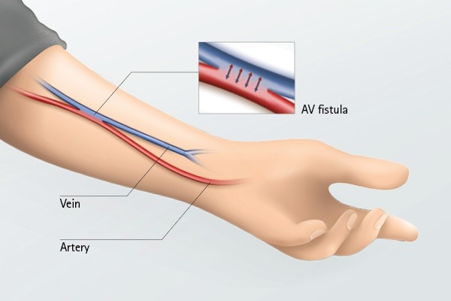

Photo Credit: [Endovascular_Percutaneous Fistula](https://www.riaendovascular.com/2019/04/22/new-dialysis-fistula-procedure/)

### Arteriovenous Graft

The arteriovenous graft (AVG) is a surgical procedure to create a connection or "bridge" between an artery and vein. A graft can be made from biologic or synthetic material. Biologic grafts are most often constructed from bovine (cow) and ovine (sheep) carotid arteries and bovine mesenteric veins. The expanded polytetrafluoroethylene (ePTFE) synthetic graft is most commonly used today.

The HeRO Graft (Hemodialysis Reliable Outflow) is commonly used in patients who would otherwise receive a central venous line catheter due to central venous stenosis and blockages. This graft is also constructed out of ePTFE material. One major difference in the HeRO graft is the 5 mm outflow into a central vein with the tip placed in the right atrium of the heart.

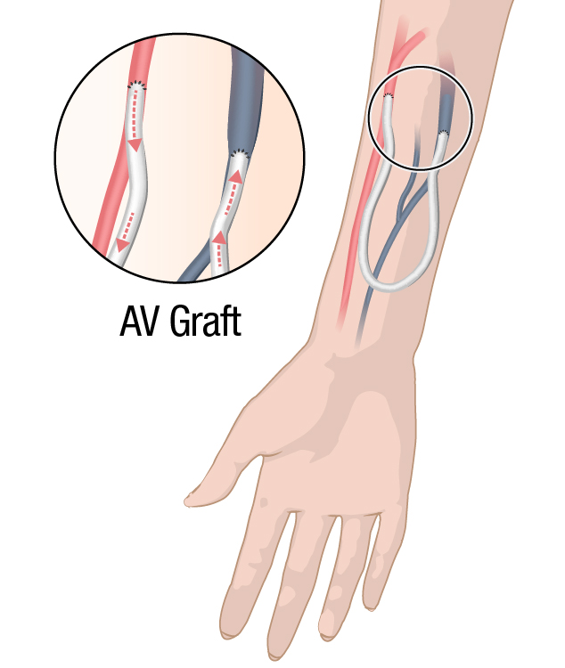Unlike the arteriovenous fistula a graft does not require maturation time. Many patients can begin using their graft within 2-3 weeks after placement and the swelling in the arm has gone down.

Thrombosis and infection are the biggest problems with grafts.

Activity 1: Have the learner feel for the thrill and listen for the bruit of a graft. Discuss the difference in the way the access feels and sounds (if any).

Activity 2: Have the learner visualize a loop graft and straight graft (if available). Demonstrate how to find the direction of blood flow.

Activity 3: Discuss and demonstrate the technique for access preparation and proper angle for cannulation of an AV graft.

Photo credit: [Centers for Disease Control and Prevention](https://northwestkidneycenters-my.sharepoint.com/personal/ercelene_kinnebrew_nwkidney_org/Documents/Be%20a%20Safe%20Patient%20|%20Dialysis%20Safety%20|%20CDC)

### Vascular Access Complications

Infiltration - occurs when the needle is inserted into the access (AVF or AVG) and out the other side of the access. Using a tourniquet when cannulating fistulas along with the correct angles for needle insertion can decrease the potential for infiltration.

Hematoma - is a pocket of blood beneath the skin causing swelling and can be painful.

Activity 1: Discuss the following with the learner.

* The correct angle for needle insertion for AVF and AVG
* Effects of an infiltrated needle on the venous or arterial pressure
* Tips to prevent infiltration.
* What to do when an infiltration occurs, where and if a second cannulation is allowed

Stenosis - a narrowing of the blood vessel that slows blood flow in an access.

Aneurysm - a bulging or weakened area in the wall of the vessel. Never place needles into an aneurysm. A surgical intervention is needed when the skin on the aneurysm is “shiny". This is a sign the fistula could rupture due to thinning of the vessel wall.

Thrombosis - a blood clot. Blood clots can form in all types of access and occur more frequently in grafts than fistula.

Activity 2: Discuss the following with the learner.

* The ladder method for cannulation and the importance of site rotation.
* The difference in the sound of the bruit when stenosis is present.

Line separation - a disconnection in the lines, a ruptured fistula or needle dislodgement. Any one of these occurrences can cause exsanguination and potential death to a patient.

Activity 1: Discuss and or demonstrate the following:

* Proper taping technique per policy
* Importance of arterial and venous pressure monitoring and what to look for with a high/low pressure alarm.
* Importance and policy for access being always visible.

Air Embolism - air introduced into the vascular space (bloodstream), an air embolism can stop the flow of blood similar to a blood clot. Dialysis machines are equipped with an air detector. There is an audible alarm, and the machine will stop when air is detected. Always visualize the venous line for air prior to resetting the alarm and resuming treatment.

Activity 2: Discuss and demonstrate the following:

* Locate the air foam detector on the dialysis machine.
* Demonstrate the left side Trendelenburg position and discuss the rationale for this position when an air embolism is suspected.

**Additional Notes**

__________________________________________________________________________________________________

__________________________________________________________________________________________________

__________________________________________________________________________________________________

__________________________________________________________________________________________________

__________________________________________________________________________________________________

__________________________________________________________________________________________________

__________________________________________________________________________________________________

__________________________________________________________________________________________________

__________________________________________________________________________________________________

__________________________________________________________________________________________________

Infection Control in Dialysis**.**

Most infections are preventable when using proper aseptic techniques and hand hygiene in the dialysis facility. Infections are the second most common cause of death in hemodialysis patients. Teaching and demonstrating infection control measures with your new learner sets the standard of expectation when caring for Northwest Kidney Centers patients.

Aseptic technique means to free from contamination caused by harmful bacteria, viruses or other microorganisms. Hand hygiene is the single most important method you can use to prevent the spread of infection. It protects you and the patient.

Activity 1: Demonstrate proper handwashing.

Activity 1: Discuss ways pathogens can enter the body and methods of prevention. *Pathogens can enter the body through mucus membranes (splash in the eye, sexual transmission, touching the nose, etc.), a break in the skin and by breathing in pathogens in dust or lint into the lungs.*

Activity 2: Discuss the 3 main ways a pathogen can spread from individual to individual.  *Direct contact such as shaking hands, indirect contact; touching objects such as dialysis chairs, blood pressure cuffs, treatment carts, etc. and droplet spread; breathing in droplets from the sneeze or cough of an infected person.*

Activity 3: Review the infection control policy with the learner and demonstrate proper hand hygiene using soap and water then alcohol-based hand rub. Discuss the proper use of the alcohol-based hand rub.

Cleaning and Disinfecting

Any items used during a dialysis treatment must either be thrown away, assigned to a patient or cleaned and disinfected before returning it to a clean area.

Activity 1: Show the learner the clean and dirty areas in the clinic. Ask the following questions.

* What would you use the dirty sink for during the shift?
* Where do you wash your hands?

Activity 2: Using Glo-Germ to demonstrate the importance of proper hand hygiene. Have the learner apply the glo-germ to their hands. Using the black light in a dark area of the clinic show the learner the artificial bacteria. Next, demonstrate proper handwashing technique followed by another view of the freshly washed hands in a dark area.

The purpose of the Glo-Germ activity is to emphasize the importance of proper handwashing to prevent the spread of germs and bacteria in the clinic.

**Additional Notes**

__________________________________________________________________________________________________

__________________________________________________________________________________________________

__________________________________________________________________________________________________

__________________________________________________________________________________________________

__________________________________________________________________________________________________

__________________________________________________________________________________________________

# Hemodialysis Complications

There have been many technological advances in hemodialysis that have helped to decrease the potential for adverse occurrences and complications. However, complications can still occur. The complication could be clinical or technical in nature. Clinical complications are related to patient care and technical complications are associated with equipment issues.

Clinical Complications

|  |  |  |  |  |
| --- | --- | --- | --- | --- |
| Complication | Signs/Symptoms | Causes | What to Do | How To Prevent |
| Hypotension  (Low Blood Pressure) | * Dizziness * Rapid pulse * Cold/clammy skin * Excessive yawning * Sweating | * Removing too much fluid * Taking blood pressure medication before dialysis * Heart disease | * Decrease UFR. * Elevate patient legs slightly higher than head. * Give saline bolus. * Notify the nurse. | * Get accurate weight before treatment. * Calculate fluid removal correctly. * Ask patient if they took any BP medication. |
| Hypertension  (High Blood Pressure) | * May be asymptomatic (having no symptoms) * Headache * Nervousness | * Fluid overload * Lack of medication adherence. * Anxiety | * Notify the nurse. * The nurse will assess the patient and provide appropriate intervention. | * Calculate fluid removal goal correctly. * Encourage adherence to medication regimen. * Reevaluation of EDW by physician. |
| Angina | * Pain or tightness in chest, arm or jaw * Patient may have trouble breathing, * Hypotension may occur. | * Hypotension * Coronary Artery Disease * Anxiety * Anemia | * Slow BFR to 150 ml/min * Decrease UFR * Monitor vitals * Give Saline bolus if hypotensive. * Call for help.   *The nurse will assess patient for additional actions.* | * Calculate fluid removal goal correctly. * Monitor blood pressure for signs of hypotension. |
| Cramps | * Painful muscle contraction in hands, feet, legs, or abdomen | * Removing too much fluid * Removing fluid rapidly * Hypotension | * Give saline bolus per clinic policy. * Decrease UFR * Verify patients BP is stable to support the patient standing. * Help patient stretch the affected muscle, gently massage the area. | * Get an accurate pre-treatment weight. * Verify the dialysate prescription. * Encourage patients to follow their recommended salt and fluid intake. * Calculate the fluid removal goal correctly |
| Air embolism  (air bubble causing blockage in the blood vessel) | * Chest pain * Coughing * Confusion * Death * Cyanosis | * Air detector broken or not armed. * A leak or loose connection in the extracorporeal circuit. | * Immediately clamp all lines. * Call for help. * Place patient in Trendelenburg on the left side.   *Discuss the rationale of this position with the new learner. Left-side T-burg position traps the air in the right ventricle of the heart.* | * Arm the air detector * Check the level of the saline bag solution. * Tighten all connections of the extracorporeal circuit. |

Technical Complications

|  |  |  |
| --- | --- | --- |
| What You See | Possible Causes | What To Do |
| Bright (cherry) red blood lines | * Hemolysis * Dialysate is too warm. * Pre pump negative pressure > 250 mmHG | * Stop the treatment * Do Not return the blood due to potential for high   levels of potassium   * Monitor patients vitals and notify the nurse. * Remove the machine from the treatment floor and tag per policy * Keep and bag all supplies from the treatment and label per policy |
| Dark blood in the lines | * Clotting * Air in the circuit * Low arterial drip chamber level | * Administer heparin as prescribed * Evaluate patient access for signs of occlusion or abnormal findings * Verify machine set and prime is completed per policy. |
| Air or Foam in the blood lines | * Empty saline bag * Underfilled drip chamber | * Clamp saline line * Stop blood pump * Place patient in Trendelenburg * Call for help |

# Appendix

# Communication Styles

The DISC tool is helpful to identify the different personality styles and ways to connect and communicate with individuals optimally. Most people are a combination of styles and often align to a primary style.

**EXTROVERTED**

**(Outgoing)**

**INTROVERTED**

**TASK Oriented**

**PEOPLE Oriented**

**D** – Dominant: Assertive, strong-willed, controlling, powerful, ambitious, decisive. May not care about other people’s emotions and appear harsh or insensitive. Famous “D” type people – Donald Trump, Michael Jordan

**I** – Influencer: Very communicative, enthusiastic, optimistic, friendly, convincing. May not keep commitments or overcommit and under perform. Famous “I” type people – Will Smith, Ellen Degeneres.

**S**- Steady: Calm, predictable, consistent, supporting, caring, deliberate, possessive. May struggle with analysis paralysis and overthinking situations. Famous “S” type people - Tom Hanks, Julia Roberts

**C**- Cautious: Careful, neat, systematic, specific, accurate, detailed, logical. May be an introvert or shy. Struggle with narrowing concepts down to one point. Slow to act if accuracy is at risk. Famous “C” type people are Bill Gates, Albert Einstein.

# Empathy Map

Empathy is the ability to understand and share the feelings of another. The empathy map can help preceptors gain a deeper understanding of the new learners’ needs as well as the patient to enhance the learning experience and interaction between the preceptor, learner, and patient.

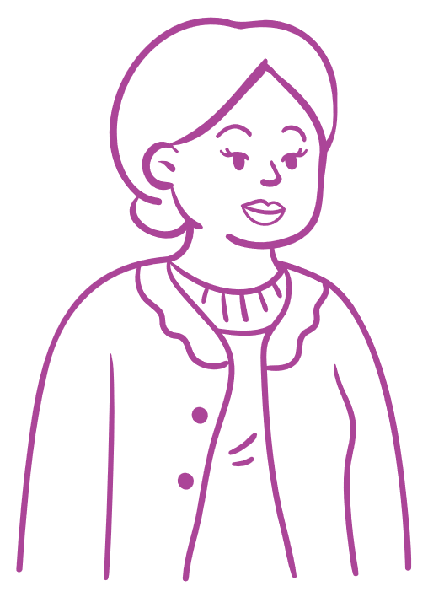

SAYS

DOES

THINKS

FEELS

# How To Provide Feedback

Providing feedback to the learner is essential to their skills development and overall success. Be aware of your surroundings when providing feedback to the learner. Positive feedback and praise should be given in public and can increase learner confidence. Constructive feedback is best given in private away from patient areas. Feedback is a tool for performance improvement and consistency.

Following the BOOST model will help provide useful feedback to the learner.

## BOOST Feedback Model

|  |  |  |
| --- | --- | --- |
| **A** | **Ask** | ask if feedback can be provided. |
| **B** | **Balanced** | positive feedback and areas to improve. |
| **O** | **Objective** | focus on behaviors and actions, not personal preferences. |
| **O** | **Observed** | describe what you witnessed. |
| **S** | **Specific** | be clear, concise, and descriptive. |
| **T** | **Timely** | frequent, and immediately upon observing a behavior. |

Examples of the BOOST method.

Ask: May I provide you with feedback? *(if the learner is not ready to receive the feedback give them a moment and state you will provide the feedback at a later time and before the end of the day.)*

Balanced: You are doing a great job with machine set up. I notice you are taking your time and have been able to troubleshoot the alarms. The more practice you have, the pace will begin to increase.

Objective: Remember to gather all the supplies you need before starting the machine set up.

Observed: I noticed you forgot to sanitize your hands after removing your gloves. It is important to properly sanitize your hands after removing your gloves to prevent cross contamination.

Specific: When you removed your gloves after cleaning the machine and placing the dirty blood lines in the biohazard container you did not wash or sanitize your hands prior to putting on a new pair of gloves.

Timely: provide feedback immediately after observing unwanted behaviors so the learner can relate to the feedback being given.

# Facility Specific Content

__________________________________________________________________________________________________

__________________________________________________________________________________________________

__________________________________________________________________________________________________

__________________________________________________________________________________________________

__________________________________________________________________________________________________

__________________________________________________________________________________________________

__________________________________________________________________________________________________

__________________________________________________________________________________________________

__________________________________________________________________________________________________

__________________________________________________________________________________________________

__________________________________________________________________________________________________

__________________________________________________________________________________________________