Clarity Monthly Update

November 2023

General Information
Visonex regularly updates Clarity with fixes to issues reported and enhancements based on user feedback. The following is a general overview of those fixes and enhancements that will be released on Sunday, November 26, 2023.

What’s Fixed in Clarity
- Date of Next Dose Issue
  - In situations where a patient missed more than one run, if the missed treatments were documented as Missed and the Medications were postponed, the date of next dose was not properly updating in the parent order when the medication was administered on the next attended treatment. This has been fixed.
  - Note: Visonex continues to work on the dose counter issue related to meds with frequency of ‘On Selected Days’ and the patient’s schedule switches from MWF to TTS or vice versa. They continue to monitor these orders and are contacting facilities to make sure these medication orders get properly updated.
- General Information
  - The Date Status Changed field was not updating to today’s date when the Status field was changed. This is now fixed.
  - Spelling errors have been corrected.
- NPI
  - There was an issue with the Physician list not loading correctly in Clarity in September and October. The list should now be refreshed as well as the NPI’s.

What’s New in Clarity
- 2024 ICD10 Catalog Update
- The Clarity ICD10 list has been updated to the 2024 List released on 9/28/2023.

- Infection Form Updates
- The Patient Infection form has been updated to incorporate the new EQRS changes for Peritonitis. Additional fields will display at the bottom of the page when one of the following Infection Sources is selected: Dialysis Access (Available) - PD Catheter, Peritonitis, PD Exit Site, or PD Tunnel.
- ‘Evidence of intra-abdominal process’ has been added to the Problems/Symptoms list.
- Effluent Cell Count now allows 6 characters.
- More fields will display if ‘Patient experience an invasive procedure within 14 days prior to peritonitis diagnosis?’ = Yes.
- Note: At this time, this information will NOT transmit to EQRS.
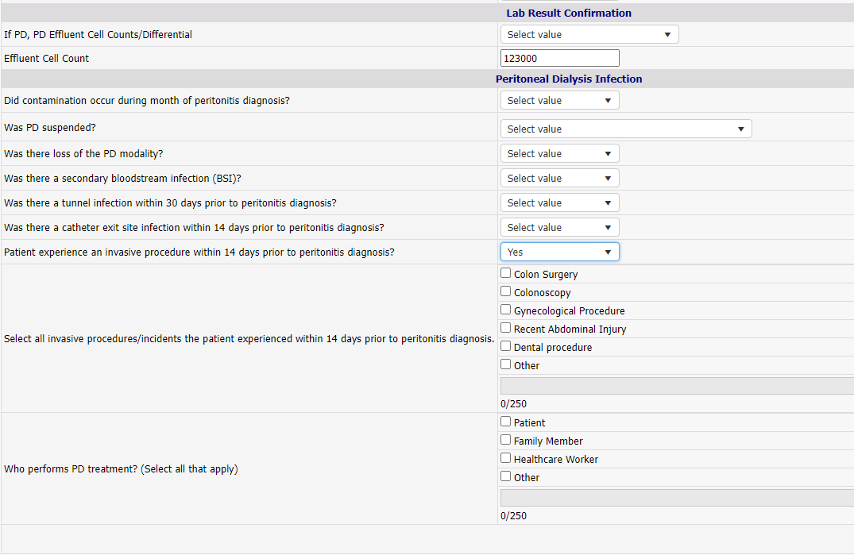

- Reports
- Hemodialysis Setup Information Report
- Now displays the patient’s Machine ID.
- Hemodialysis Treatment Summary Report
- This is like the RTC – Hemodialysis Treatment Information report but can be customized to display only specific items from RTC. Please submit a request to IT Support to request customizing this report.

- Patient Schedule New Remove from Schedule Task
- ‘Other – Remove from Schedule’ has been added to the Task dropdown for use when other options do not apply.

- Patient Portal
- Patients that have Staff-Assisted Treatments can now document their treatments in Patient Portal.

- Problem List
- There is now a search function in Problem Lists.
- The Start and End Date columns have been moved.
- Updated by and Last Update columns have been added.

- Treatments>Sodium & UF Profile
- Last Update and Updated by columns have been added.

Clarity Guides and Tip Sheets – On KNET
- Clarity User Guides by Role: K-Net - User Guides by Role (nwkidney.org)
- Clarity Tip Sheets: K-Net - Tip Sheets (nwkidney.org)

