Clarity Monthly Update

June 2023

General Information
On a monthly basis Visonex updates Clarity with fixes to issues reported and enhancements based on user feedback. The following is a general overview of those fixes and enhancements that will occur on Sunday, June 25, 2023.

What’s Fixed in Clarity

- E-Signature-Unable to sign off physician orders
  - Care Team Roles of Physician Assistant and Advanced Practice RN now have the same rights for E-Signature as a Physician or Physician Extender.

- RTC Hemodialysis Treatment Report is Blank
  - Visonex fixed an issue causing the RTC Hemodialysis Treatment Report to be missing certain dates and certain patients even though the patients did have RTC treatments.

- Patient Summary Report Display Order
  - Visonex updated the Patient Summary report to display order of labs, medications and blood pressures by most recent first. The report now displays information in the same order as checklists.

- RTC-Dry Weight on the PreTreatment Tab Updating when 2nd user saves
  - Visonex fixed the issue causing the Dry Weight to become unchecked when a 2nd user saved data on the PreTreatment tab of RTC

What’s New in Clarity
- Patient Chart View-All Kt/V values display in Adequacy/Recirc section
  - Prior to change, Standard Kt/V values and PD Kt/V values would display in the Adequacy/Recirc section, but 3x/wk in-center Kt/V values would display in the Z-Unknown section.
  - Now all Kt/V values will display in the Adequacy/Recirc section.
  - 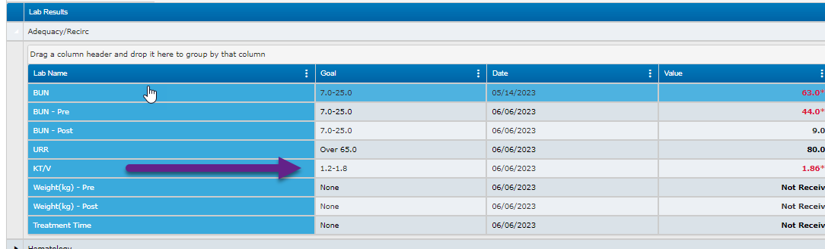

- RTC>Post Treatment tab- Pre Weight
  - The Pre Weight will now display in the Post Treatment tab to make it easier to compare pre and post weights.

  - 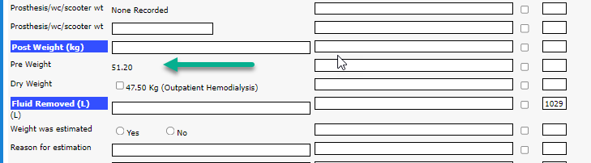

- Checklist Library Item-HD/PD Prescription BP Parameters
  - Visonex created a new checklist library item that pulls the BP parameters from the Hemo or PD prescription(s).

- Updated Organization Management Reports
  - Visonex updated the following reports in Organization Management to include Multifactor Authentication (MFA) information.
    - Failed User Logon Attempts
    - Logon Attempts by IP Address
    - Logon Attempts by User
    - User Logon Attempts

- EQRS- Sending Nursing Home Information
  - Clarity now sends Nursing Home information to EQRS along with the reason for the nursing home stay (Permanent Resident, Short Term Care/Rehabilitation or Other).
  - Staff can document this information in Clarity by going to Registration>Nursing Home History.

Clarity Guides and Tip Sheets – On KNET
- Clarity User Guides by Role: K-Net - User Guides by Role (nwkidney.org)
- Clarity Tip Sheets: K-Net - Tip Sheets (nwkidney.org)

