
How to Document Refusal of an Immunization

There are two ways to document an immunization as “Refused.”

These scenarios are for patients who refuse to get the immunization ever during this flu season. If the patient is simply declining for now/today, you will Postpone the immunization.

In both scenarios, the immunization must first be entered as “Scheduled in Clinic” in the Immunization Screen.

An immunization can only be scheduled for “today” or the future. Also, the immunization can only be scheduled on a day the patient has an appointment in Patient Schedule.

Primary Workflow: A patient refuses when the RN goes to administer the injection.

- Enter the immunization as Scheduled in Clinic in Immunizations
- Go to RTC or VM>Medications/Imn tab and mark it “Not Administered.”
- When you check the “Not Administered” radio button, it will open another field and require you to enter the Reason for Refusal. If there is no medical reason for the refusal, select “Personal.” Save the change and when the tx is posted, it will update the Immunizations screen.

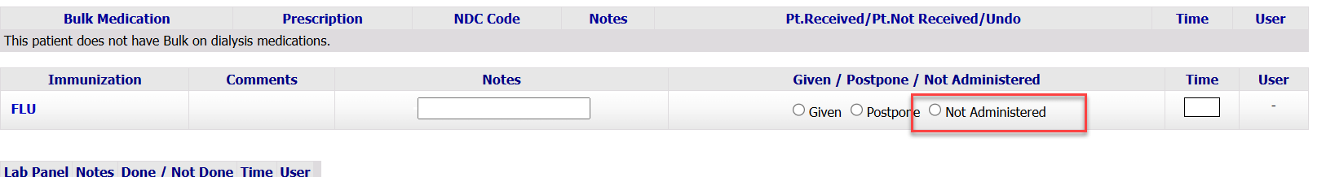

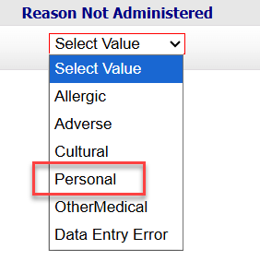

Secondary Workflow: The patient tells you up front that they don’t want to get the vaccine, so you do not intend to have it given during tx, but you do want a record of the patient refusing it.

- Enter the immunization as Scheduled in Clinic in Immunizations
- After you have saved/added that entry, open it again.
- Change the status from Scheduled in Clinic to Not Administered and document the reason why.

- NOTE: If you have entered the Scheduled in Clinic Immunization Date and the patient has an RTC or VM session created (open but unposted or posted) on that date, Clarity will force you to go to RTC or VM to document the Not Administered. It will try to make you go through the primary workflow. This secondary pathway should only be used if the patient does not have an RTC or VM session already created for that date.

