**In-Center Patients**

* **Enter Scheduled in Clinic Immunization Order**

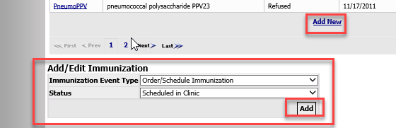

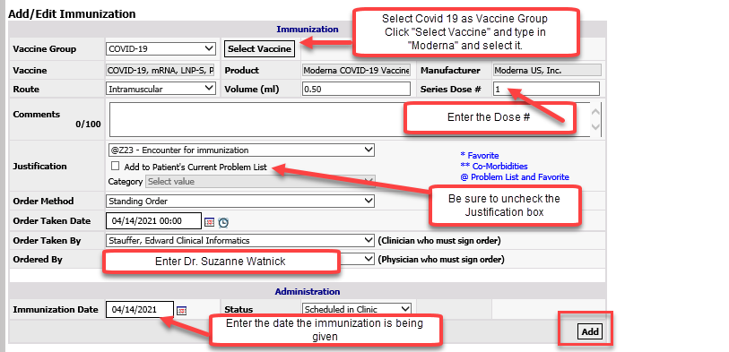

* **Document the Immunization as “Given” in RTC**

Hard copies of completed intake/consent forms need to be **scanned** routinely in the day to [Jennelle.Murphy@nwkidney.org](mailto:Jennelle.Murphy@nwkidney.org) and **hard copies placed in prelabeled envelopes** to Jennelle Murphy at Enumclaw.