In-Center Patients

- Enter Scheduled in Clinic Immunization Order
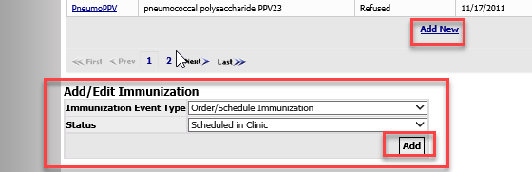

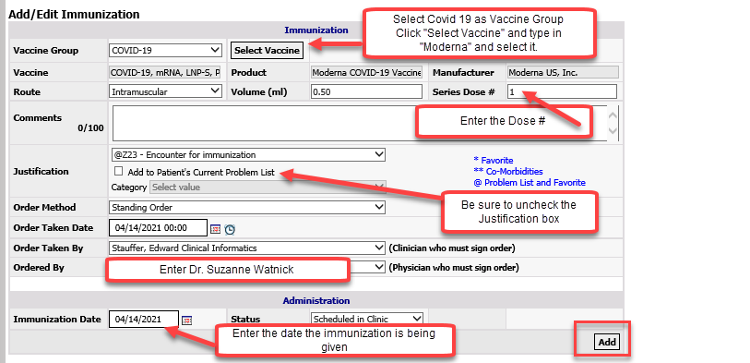
- Document the Immunization as “Given” in RTC
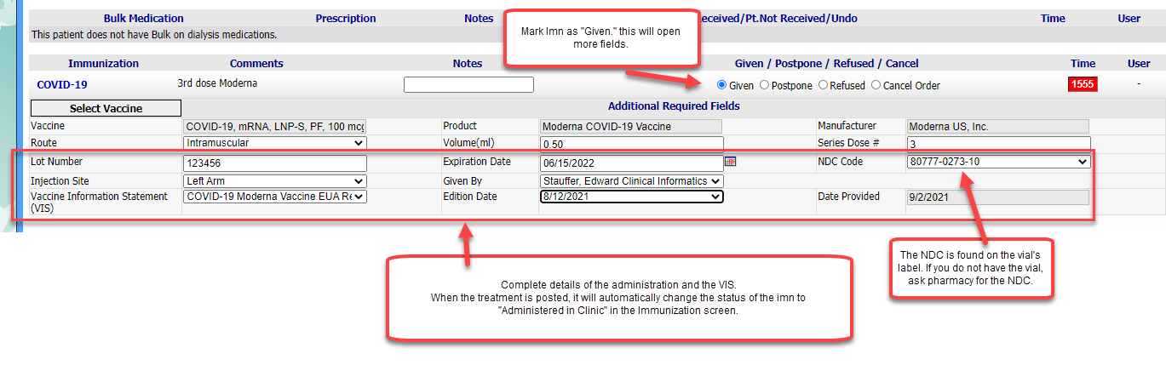Hard copies of completed intake/consent forms need to be scanned routinely in the day to Jennelle.Murphy@nwkidney.org and hard copies placed in prelabeled envelopes to Jennelle Murphy at Enumclaw.

