Home Patients

* **Enter Scheduled in Clinic immunization order (Patient>Immunizations)**

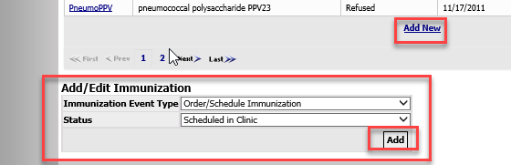

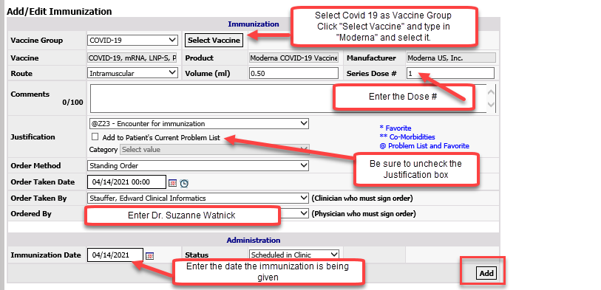

* **Document the immunization as “Given” in Visit Management (you will have to create an Office Visit first).**

Hard copies of completed intake/consent forms need to be **scanned** routinely in the day to [Jennelle.Murphy@nwkidney.org](mailto:Jennelle.Murphy@nwkidney.org) and **hard copies placed in prelabeled envelopes** to Jennelle Murphy at Enumclaw.