Home Patients
- Enter Scheduled in Clinic immunization order (Patient>Immunizations)
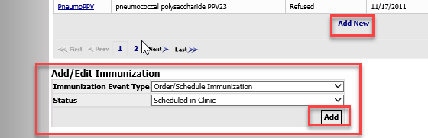
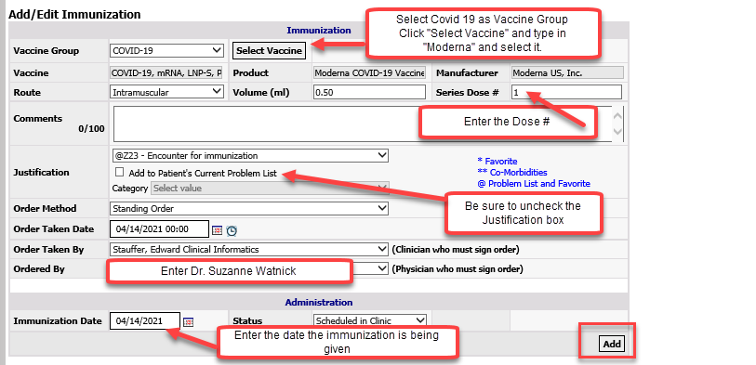
- Document the immunization as “Given” in Visit Management (you will have to create an Office Visit first).
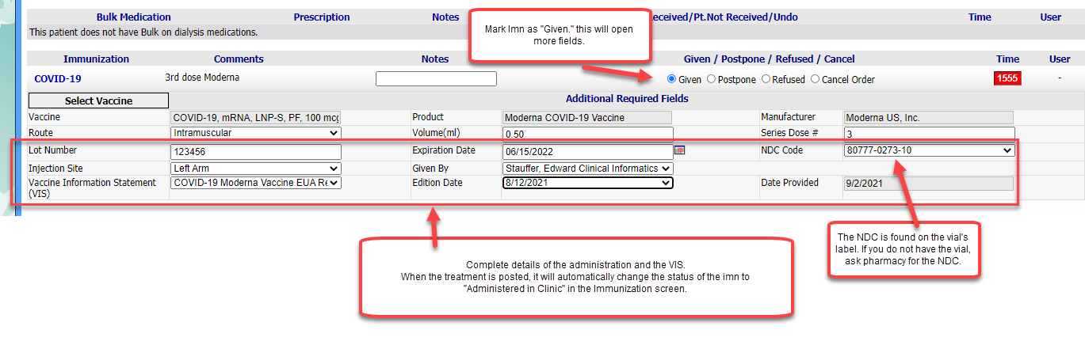Hard copies of completed intake/consent forms need to be scanned routinely in the day to Jennelle.Murphy@nwkidney.org and hard copies placed in prelabeled envelopes to Jennelle Murphy at Enumclaw.

