TRANSPLANT DOCUMENTATION

* This tip sheet describes the changes to the Transplantation Module (Now called **Transplant Management**).
  + The old “Transplant Information” screen has been split into 3 different sections
  + 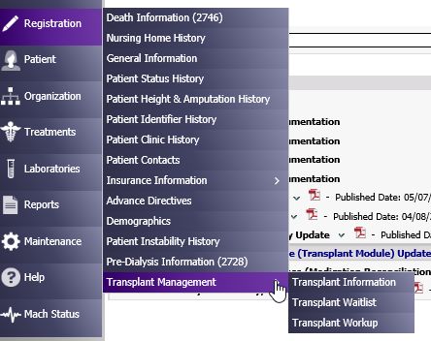
    - **Transplant Information**
      * Document actual transplants
      * This screen will be updated/maintained by the Nurse
        + Date of Transplant
        + Type of transplant

Living Related

Living Non-Related

Deceased

Unknown

* + - * + Hospital

The list of transplant hospitals/programs is maintained by CIS. If one needs to be added, send a Helpline email to notify CIS.

* + - * + Transplant Functioning?
        + Date Returned to Regular Dialysis (if transplant is not functioning)
        + Comments text box
        + Example of Transplant Information screen
  + 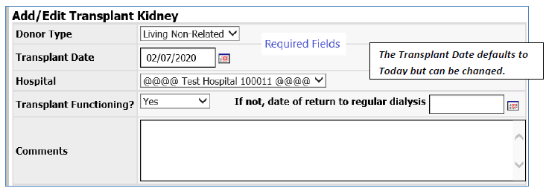
  + If adding a new transplant entry:
  + 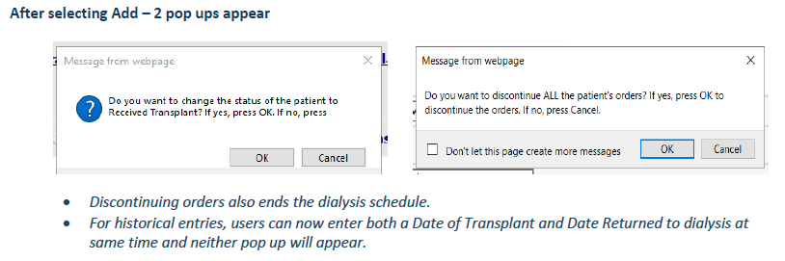
  + ***It is very important to send a Helpline email with “CIS” in the subject line so that the change in status can be entered in TIME as soon as possible because the patient needs to be transferred out of NKC to the Transplant Program.***
  + As soon as the patient receives a kidney transplant, they are no longer NKC’s patient. They become the responsibility of the transplant center and the transplant nephrologist becomes the primary nephrologist.
  + It does not matter whether the kidney has started functioning yet.
  + If the patient needs dialysis in support of the transplant, the Transplant Nephrologist will request it with new orders and the patient will dialyze as an Acute Outpatient (AKI).
* **Archived Information**
  + A Patient Note type, “Transplant Note” has been created. Any information that was in the old Transplant Information screen was migrated to a patient note and a notation was created in the current Transplant Information screen.
  + See example below.
  + 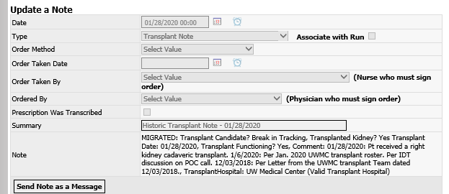
  + 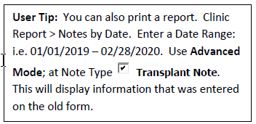
  + 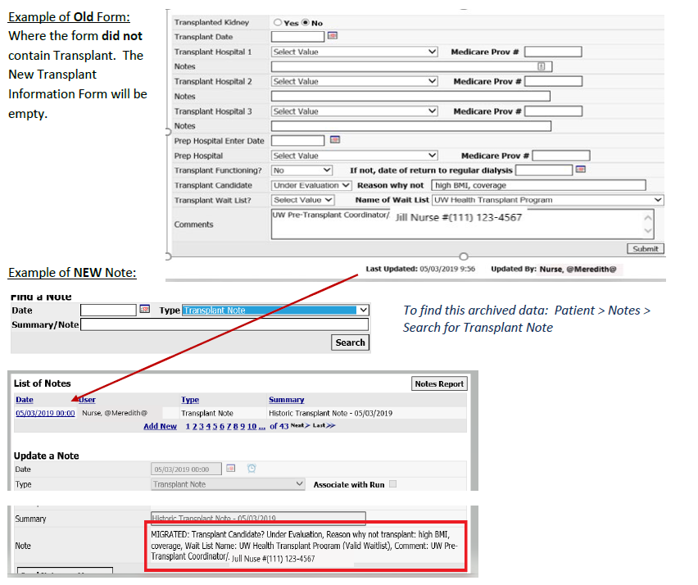
  + 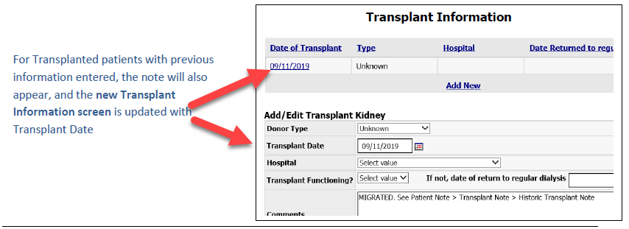
    - **Transplant Waitlist**
      * Document Transplant program referrals and current status
      * This screen will be updated/maintained by the Social Worker
        + Updated Date
        + Transplant Waitlist

More hospitals/programs can be added to the dropdown list.

Send email to Helpline with “CIS” in the subject line and request to add the hospital.

* + - * + Current Status

This list matches what UNOS and OPTN use and send to CROWNWeb.

Active

Pending Addition

Temporarily inactive

Removed

* + - * + Active Date
        + Living Donor
        + Reason if Inactive
        + Date Removed (from waitlist)
        + Example of Transplant Waitlist screen

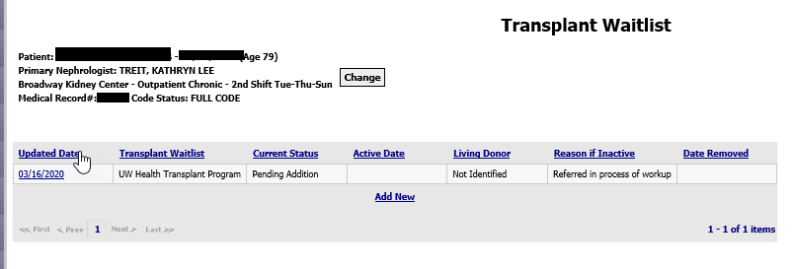

* + - **Transplant Workup**
      * Documentation of Transplant Workup
      * Updated/maintained by the Social Worker or Nephrologist.
      * Can only be updated by completing a new Transplant assessment or Physician CIA (Splitter)
      * You cannot update this screen directly.
        + Date of Checklist
        + Patient Interest

Yes

No

N/A

This was set by Visonex: no options for Undecided or Needs More Information. SW will need to document in Reason NOT Interested text box to cover these two situations.

* + - * + Reason NOT Interested: text box
        + Candidate (Transplant Candidate Status)

Referred, Listed, Active

Referred, Listed Hold

Referred, Not listed, Living donor only

Referred, Not Listed, Declined

Not Listed, Declined-Extra Follow Up Needed

Not Referred, Not Currently Eligible

Not Referred, Extra Follow Up Needed

Break in Tracking

* + - * + Reason NOT a Candidate: text box
        + Date Referred to Transplant Center
        + Transplant Center
        + First Visit to Transplant Center Completed
        + Workup Completed

Yes

No

In Progress

On Hold

* + - * + Example of Transplant Workup screen.
* 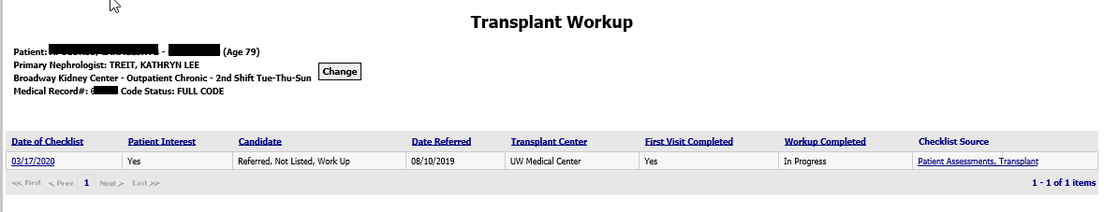
  + - **Transplant Assessment**
      * Information from the bottom section of this assessment flows to Transplant Workup screen.
      * Social Workers can use this assessment independent of CIAs

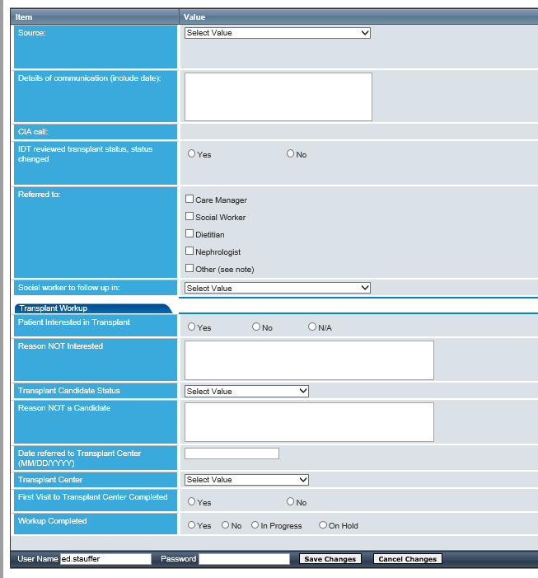

* Checklist libraries have been inserted in other assessments (MD splitter, Psychosocial, RN splitter, CIA, Transplant).
* **Psychosocial Assessment transplant changes**
* Inserted Previous Kidney Transplant, Open Transplant Waitlist and Last Transplant Workup checklist libraries so SW can see everything at a glance.
* 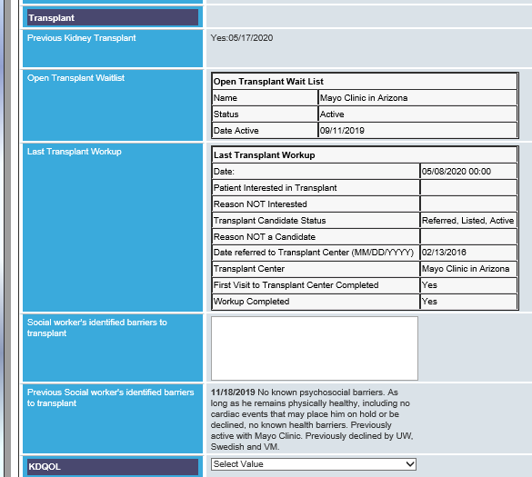
* **Physician CIA (Splitter) transplant changes**
* Inserted Last Transplant Workup checklist so MD can confirm transplant status. If not correct, the MD will complete as much of the Transplant Workup checklist section as they are able. The transplant plan of care text box will flow to the CIA lumper.
* 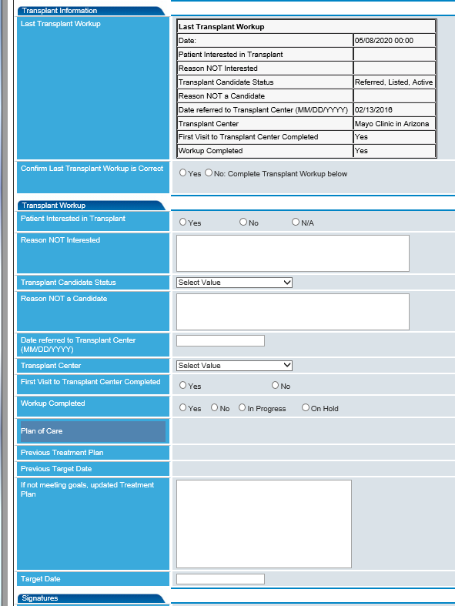
* **Nursing Assessment (CIA) transplant changes**
* Added the Last Transplant Workup checklist library so nurse can review with patient and confirm patient’s understanding of their transplant status.
* 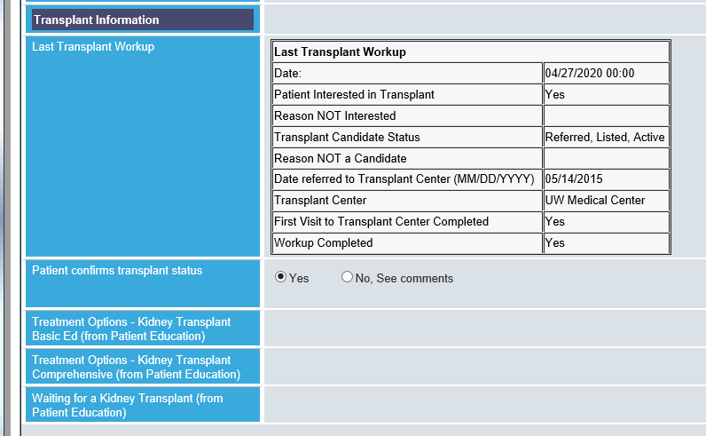
* **Comprehensive Interdisciplinary Assessment**
* Moved Psychosocial section to follow MD section so the two transplant sections are together. The MD Transplant Plan of Care text box flows from the MD splitter. The Last Transplant, Open Transplant Waitlist and Last Transplant Workup checklist libraries have been added so the patient can review them before signing the CIA.
* 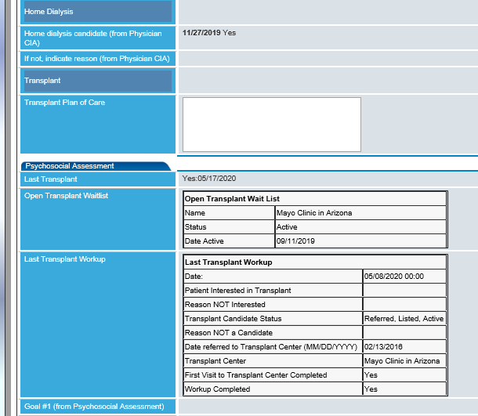
* Report: **Transplant Waitlist** (Reports>Report Wizard>Transplant Waitlist)
  + The ESRD QIP was set to have dialysis facilities increase patients on the Transplant Waitlist. The Organ Procurement and Transplant Network (OPTN) is the data source for waitlist information. This report is designed to help facilities review patients’ current, open waitlist information and should be run on a monthly basis.
  + It displays each patient and their current information about waitlists.
  + It displays CMS QIP exclusions (Age is 75 or older or the patient is in a nursing home.
  + A summary is provided based on patient age, category and transplant waitlist status. If the patient has more than one transplant program waitlist status, the patient will count in each category.
* 