Medication Reconciliation

New CMS rules implemented January 2020 require dialysis organizations to perform monthly medication reviews/reconciliations.

In Clarity, we will complete a Medication Reconciliation assessment. To get to the assessment form, go to Patient>Patient Assessments and select Medication Reconciliation. There is one form that all disciplines will use for monthly, post-hospitalization and new patient med recs.

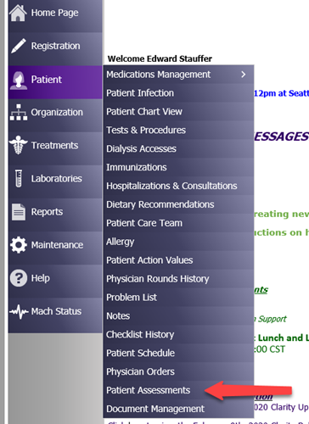

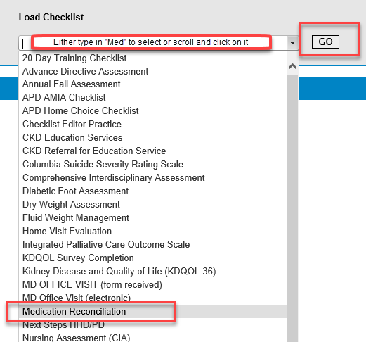

Click on the dropdown arrow next to “History.” You will see any previous assessments created. To create a new one, click Add New. Always create a new assessment each month. Do not edit the previous one for the new month.

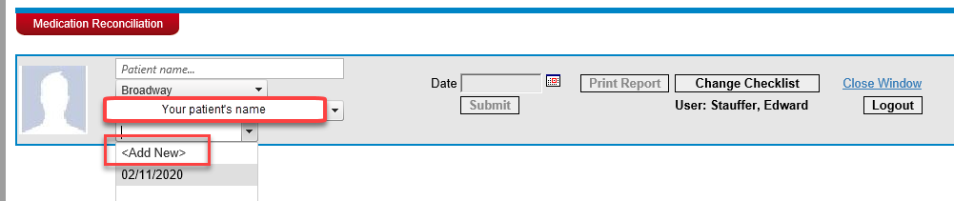

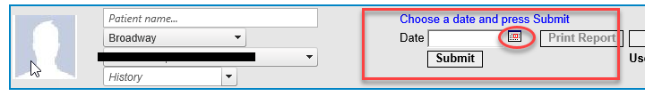

You can click on the day on the calendar or for a new one “today,” you can click on the big button at the bottom of the calendar.

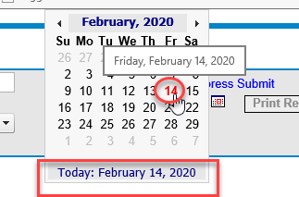

Click Submit and then click Create Checklist

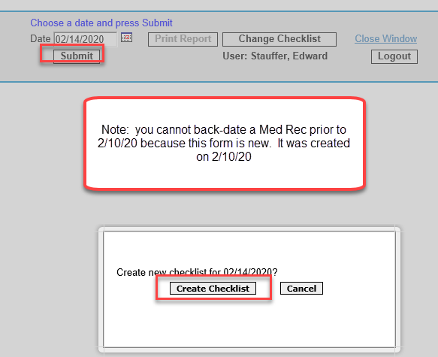

Previous versions of the Med Rec have been retired and given the prefix, “zDNU.” The “z” makes it fall to the bottom of the list alphabetically. “DNU” means, “Do Not Use.”

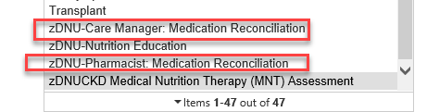

The retired assessments can still be viewed in Patient>Checklist History.

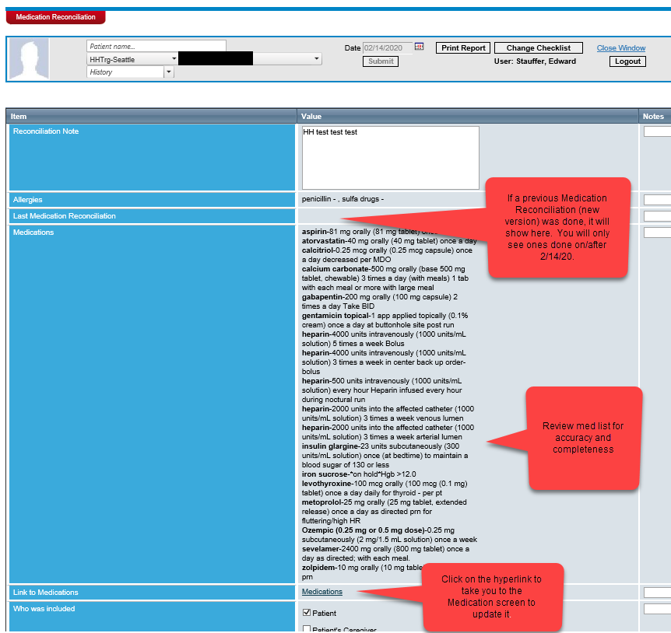

After you have updated the medication list, click Save Changes at the bottom of the screen. Wait for the data to save and then click F5 on your keyboard to refresh the Medication Reconciliation. This will update the Medications list within the Med Rec assessment.

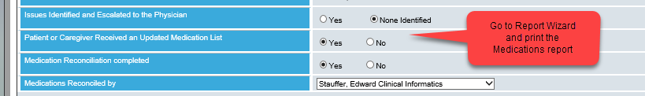

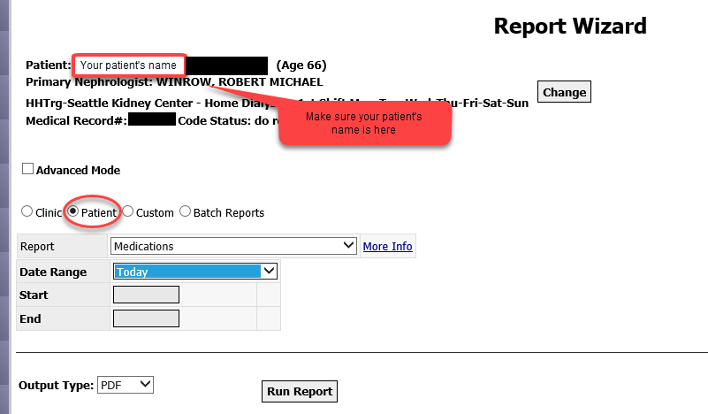

The Medication Reconciliation assessment will automatically create an entry in Patient>Medication Management>Medication Review and Reconciliation. The Type will be “Reconciliation” and the Source will be “Patient Assessments, Medication Reconciliation.” This is what gives us “credit” for doing the monthly Med Rec. This flows to CrownWeb, Reports and RTC and VM.

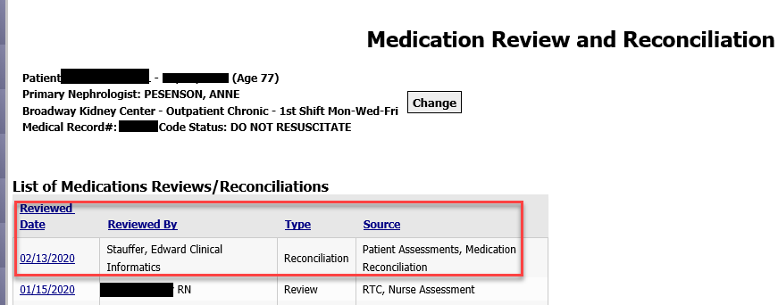

Staff should never use the Add New button in this screen. The Medication Reconciliation assessment is the only way we want to create an entry.

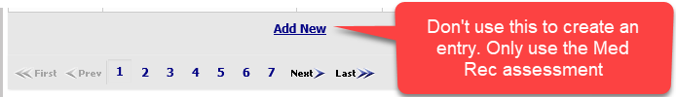

Completing a Medication Reconciliation will also automatically create a patient note in Patient>Notes. If you click on the date, you can see a summary of the assessment that was completed.

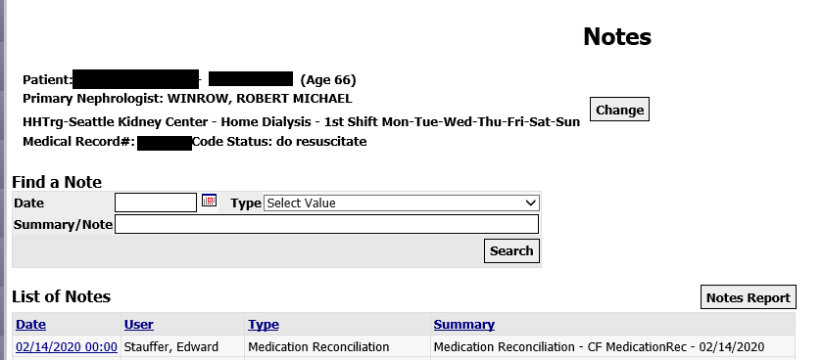

You can check to see if a patient is due for a monthly Medication Reconciliation while in RTC>Nurse Assessment, VM HH>General Assessment or VM PD>Visit Assessment. Complete the Med Rec for the month as early as possible.

RTC:

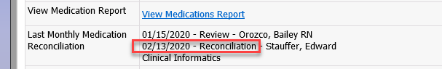

VM HH:

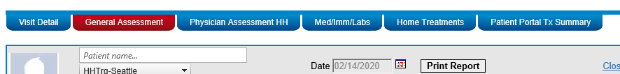

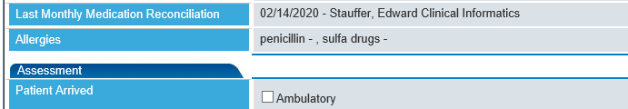

VM PD:

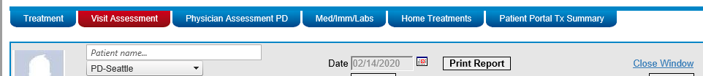



***We are not able to embed a link within RTC or VM that takes you to the Medication Reconciliation assessment. You must go to Patient>Patient Assessments to create a new one.***

You can also use Report Wizard to see who has not had a Medication Reconciliation completed for a date range.

If you use the Clinic report: Medication Reviews and Reconciliations, it will list only the patients who HAVE NOT had one done in the date range.

If you use the Patient report: Medication Review/Reconciliation for Patient, it will show you if the patient(s) selected had one completed or not. If you want to run this report and include all the patients in your clinic, follow the steps for using Advanced Mode below.

You can use Advanced Mode to select a single patient in a Clinic report, select all patients in a Patient report or to modify which Clinics, Shifts, Patient Statuses, Care Providers or Groups are included in the report.

NOTE: “InPatient” status is considered an inactive status by Clarity. In most reports, Clarity will not include patients who are in the hospital. You should always use Advanced Mode to add InPatient status to your report.

To use Advanced Mode to select a single patient to appear on a report that is only found in the Clinic dropdown list, go to Report Wizard.

Click on the Patient radio button. If you do not see your patient’s name, click on Change and search/select them.

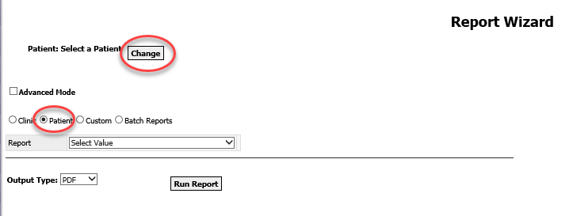

Click on the Clinic radio button and select your report, shift and date range if applicable.

Click on the Advanced Mode check box

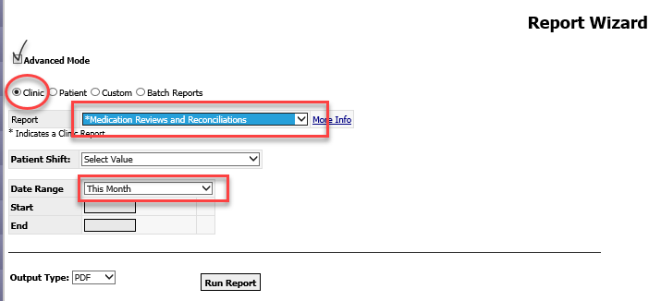

You will be taken to another screen. Click on the Next box at the bottom of the screen.

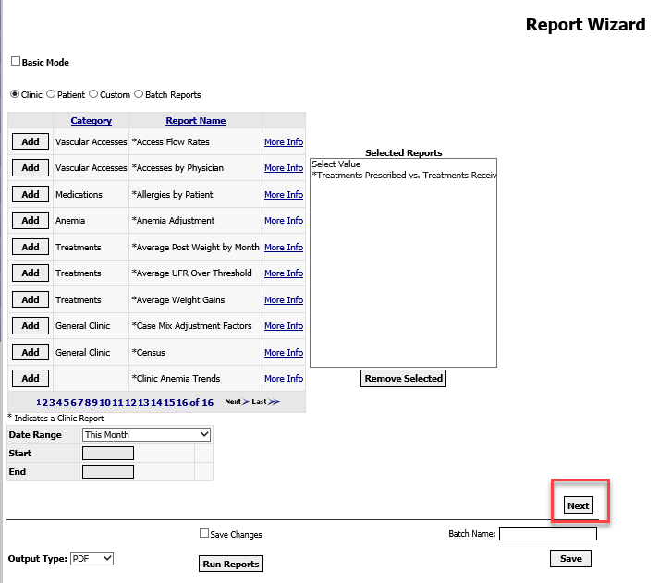

Click on the clinic name that defaults in the box and click Remove.

Click on Add to Selection next to your patient’s name. The patient’s name will now appear in the Selected Patients box. This report will now only pull data for this patient.

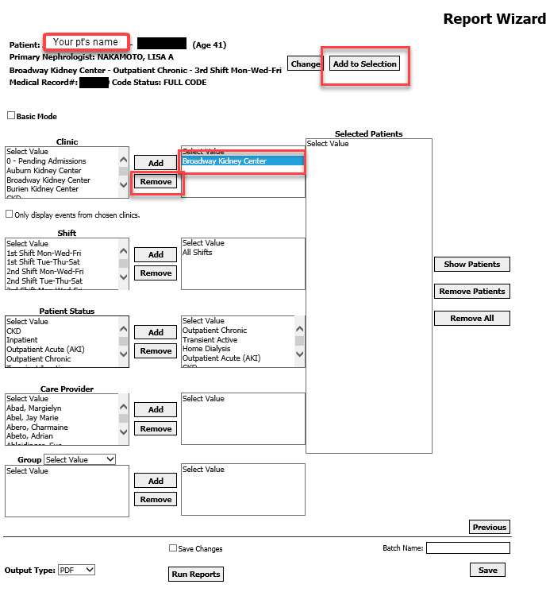

Click on Run Reports.

To run a report only found in the Patient report list for the entire clinic or multiple patients, go to Report Wizard.

Click on the Patient radio button and select the report. Select Date Range if applicable. Check the Advanced Mode box. Click Next on the following page.

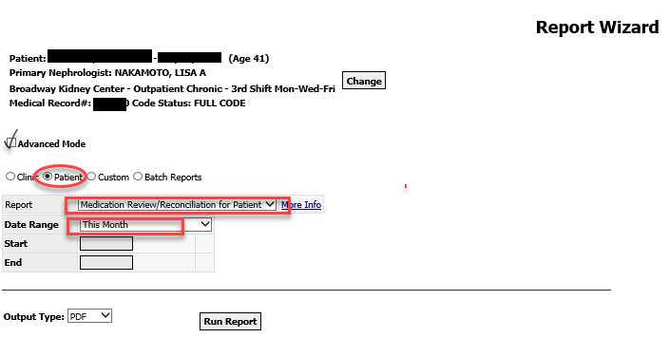

Your default clinic will show in the Clinic box. If you would like to add more clinics, select from the Clinic box and click Add. If you would like to remove some patients from the report, Click on Show Patients and then click on each patient’s name and then click Remove Patients.

Add Inpatient to selected Patient Statuses and then click Run Reports.

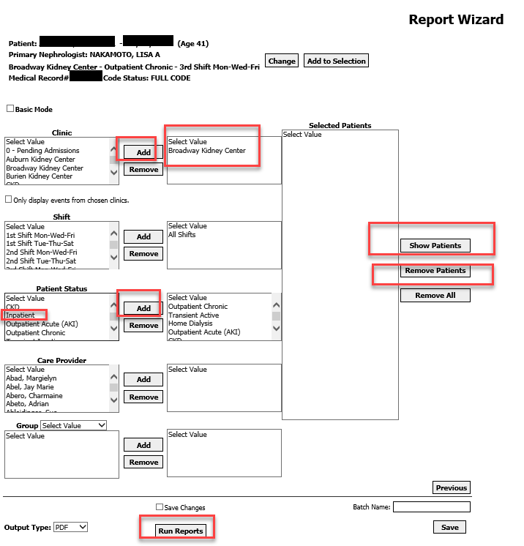

Example of the Clinic: Medication Reviews and Reconciliations report

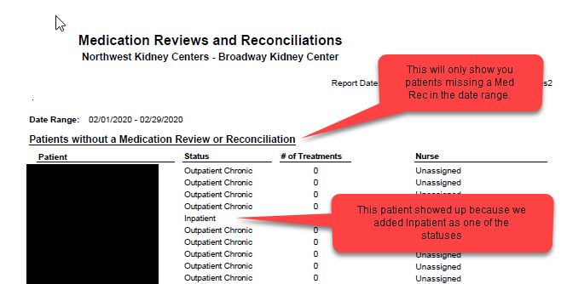

Example of the Patient: Medication Review/Reconciliation for Patient report

