**Scanner Upload Troubleshoot**

You may encounter a PAR Count upload issue. Follow these steps to make it work.

1. Click Requisitioning >> PAR Counts >> PAR Count Upload >> Upload Data

This message appears.

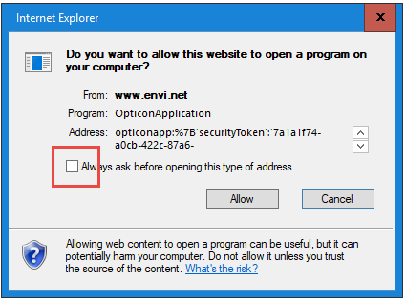

Un-check the box “Always ask before opening this type of address” then click **Allow**.

1. This message appears.

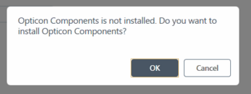

Click **Cancel**.

1. Double click the “Opticon Application” icon at the bottom right corner.

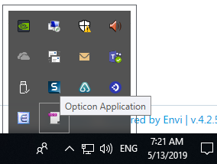

1. This box appears

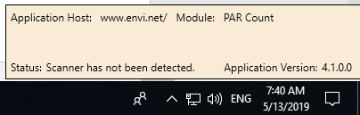

* If you see the following pop-up message, click **Cancel**.

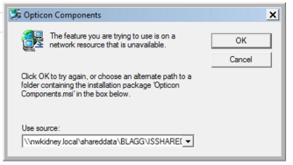

* If you see the following pop-up message, click **OK**

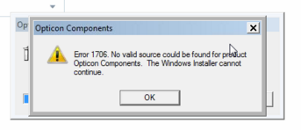

* If you see the following pop-up message, click **Yes**.

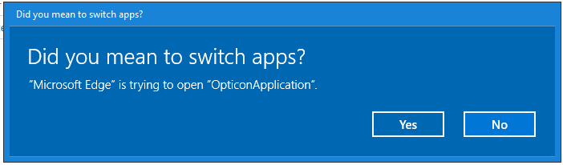

1. Click “Upload Data” again.

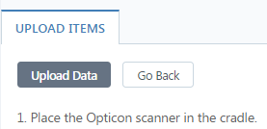

You will see the data upload processing at the bottom right.

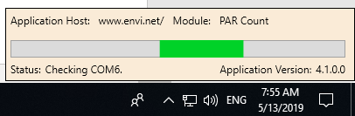

You will get this message

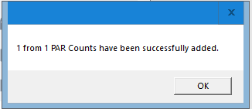

**Note: If you scanned more than one bar codes, you only need to upload once.**

Contact Helpline, 206-292-2579 or x2579, [helpline@nwkidnery.org](mailto:helpline@nwkidnery.org), if you need help.