Scanner Upload Troubleshoot
You may encounter a PAR Count upload issue. Follow these steps to make it work.
- Click Requisitioning >> PAR Counts >> PAR Count Upload >> Upload Data
This message appears.
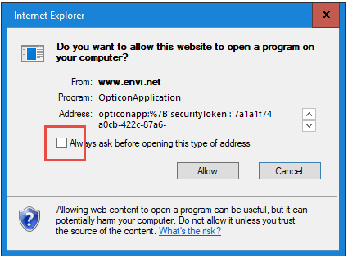
Un-check the box “Always ask before opening this type of address” then click Allow.
- This message appears.
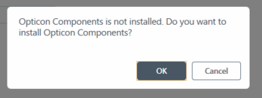
Click Cancel.
- Double click the “Opticon Application” icon at the bottom right corner.
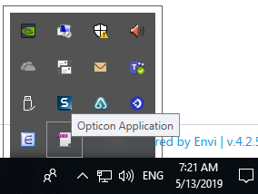
- This box appears
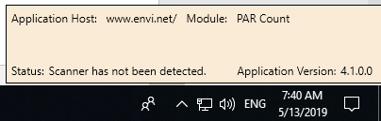

- If you see the following pop-up message, click Cancel.
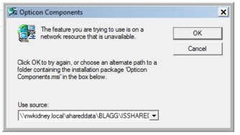
- If you see the following pop-up message, click OK
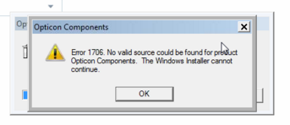
- If you see the following pop-up message, click Yes.
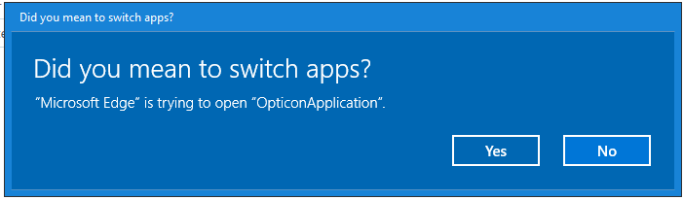
- Click “Upload Data” again.
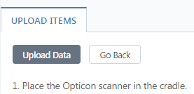
You will see the data upload processing at the bottom right.
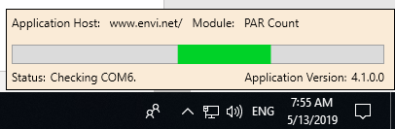

You will get this message
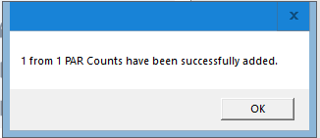
Note: If you scanned more than one bar codes, you only need to upload once.

Contact Helpline, 206-292-2579 or x2579, helpline@nwkidnery.org, if you need help.

